降低正交分頻多工傳輸之非線性效應之研究
Study of Mitigation of Nonlinear Effect in OFDM Transmissions

研 究 生：卓 立（Li Cho）
指導教授：許超雲（Prof. Chau-Yun Hsu）
大同大學
通訊工程研究所
博士論文

Dissertation for Doctor of Philosophy
Graduate Institute of Communication Engineering
Tatung University

中華民國 一○九年六月
June 2020
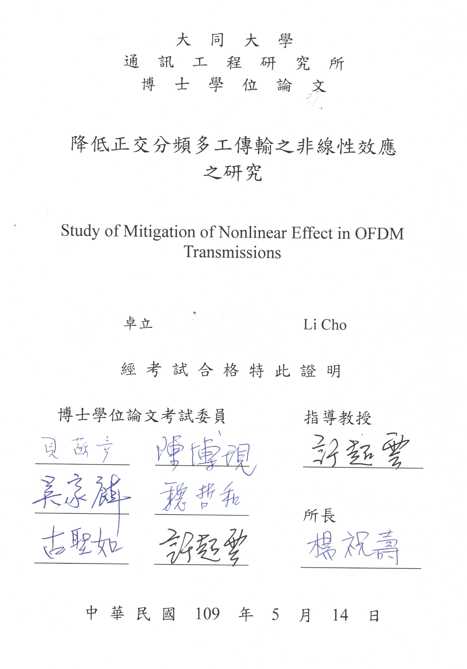

ACKNOWLEDGEMENT
自碩士畢業，從未想過自己會再次踏入母校帶職攻讀博士，更沒想到因著對研究的熱愛，最後竟辭去工作，全力投入研究工作。全職博生的生活，對於已成家且育有兩子的我來說，何其珍貴；能與三年前甫上幼稚園的女兒一起進入學校，如今順利一起畢業，無非是神極大的憐憫與恩典，願一切榮耀、頌讚都歸予祂！
首要感謝的是指導教授許超雲院長，自回母校就讀博班後，老師極力爭取各樣產學合作案，使我能在投入研究的同時與業界接軌，並補貼家用。在研究上，對我高度信任，在帶領學弟妹的碩士論文及專題研究時，均給予足夠的發揮空間與支持。在論文口試審查上，感謝台灣大學貝蘇章教授、吳家麟教授、清華大學陳博現教授、本校魏哲和教授、汪順祥教授、劉皆成教授、陳建華教授、古聖如教授於百忙之中撥冗出席論文口試及資格審查會，所給予之寶貴意見，使本論文得以更臻完善。同時，亦感謝楊祝壽主任於畢業的最後一年，提供我大學部兼課磨練的機會，並以私校土博的過來人身分不斷鼓勵我，讓我能夠繼續前行。
博士班修業期間，感謝同學俊緯陪我一起以資深學長身分重返校園，使我的實驗室生活不至於孤單，並在產學合作案上給予諸多的協助，低潮時能互相打氣。感謝博士班學長玄鈞、碩士班學弟嘉暉、政宇、桀克、如達、英豪、又銘、以信、顯華、黃偉、哲維、亦凡、煒傑、律焜、宣德、宗皓、專題生學弟孟凡、聖翔、宏翊，沒有你們一起投入研究、教學相長，畢業必定遙遙無期。此外，感謝前同事正翰博士的經驗傳承、大專團契弟兄姊妹們的代禱，使我的研究之路輕省許多。
最後，家人裡特別感謝愛妻映梅，在攻讀博班收入銳減的這段期間，始終鼓勵我追求夢想；可愛的女兒希希常關心我的論文進度，問我口試第幾名；兒子旺來也常給予燦笑或爆哭化解我論文卡關時的憂鬱。感謝妹妹卓伊、妹婿睿恩一直以來的代禱與關懷以及表妹以萱協助潤飾論文。至於我的父母，您們從一開始極力反對到最後變成全力支持，如此無條件的接納與愛無疑是我攻讀博士學位期間最重要的精神支柱，我愛您們。

ENGLISH ABSTRACT
The multiple radio access technologies (multi-RATs) comprise of many popular wireless communication systems, e.g., 3GPP cellular (LTE/NR), 3GPP non-terrestrial networks (NTN), low-power wide-area networks (LPWAN), IEEE 802.11 series, and device-to-device (D2D) communications, to support various 5G services. Most of them utilize orthogonal frequency division multiplexing (OFDM)-based waveform, i.e., cyclic prefix (CP)-OFDM and discrete Fourier transform spread OFDM (DFT-s-OFDM) that may consume unnecessarily high power due to the malicious effects of a large peak-to-average power ratio (PAPR). This is particularly a problem for power-limited user equipments (UEs) under the D2D, NTN, and LPWAN systems, where high PAPR signals may drive the power amplifier (PA) to operate with large input back-off (IBO).
In this study, we address the PAPR issue in a proper manner according to the characteristics of different use cases. For D2D and NTN communications, improved generalized precoding (GPC) and polynomial cancelation coded (PCC)-DFT-s-OFDM are proposed for low-PAPR transmission. Both schemes are based on DFT-s-OFDM and can adjustably reduce the PAPR at the transmitter with the trade-off of spectral efficiency. To make PCC-DFT-s-OFDM deployment easier, we also proposed its bit-level implementation at the transmitter which is highly-compatible with LTE/NR standards. For 802.1ah in LPWAN communications, iterative subcarrier regularization (ISR) based on Extended Papoulis-Gerchberg Algorithm (EPGA) is proposed as a receiver-side scheme for improving the UE power-saving. It follows the design principle of Internet of Things (IoT) system that leaves all possible complicated computations performed at the access point while making the IoT-based UEs as simple as possible. ISR exploits the prior information specified in the 802.11ah protocols and the system-built-in functions such as fast Fourier transform (FFT) and hard decision operations in the RF module to compensate for the distorted signal affected by the PA nonlinearity. Comprehensive numerical results show that the proposed schemes can regulate the extent of IBO reduction to meet different requirements for various communication scenarios, conducting the mitigation of the unfavorable effects of PA nonlinearity adaptably. Such advantage contributes UEs to further power saving or coverage increasing according to the requirement of scenario in 5G services.
Keywords: Orthogonal frequency division multiplexing (OFDM), discrete Fourier transform spread orthogonal frequency division multiplexing (DFT-s-OFDM), peak-to-average power ratio (PAPR), polynomial cancellation coding (PCC), 5G waveform, nonlinear noise, Papoulis-Gerchberg algorithm, 802.11ah, low-power wide-area (LPWA) communications.

CHINESE ABSTRACT
多重無線電存取技術（multi-RAT）藉由多種主流的無線通信系統來支持各類5G服務，例如3GPP蜂巢式網路（LTE / NR）、3GPP非地面網路（NTN）、低功耗廣域網路（LPWAN）、IEEE 802.11系列技術以及裝置對裝置（D2D）通訊技術等。它們大多採用基於正交分頻多工（OFDM）的波形，即循環前綴（CP）-OFDM和離散傅立葉變換展頻OFDM（DFT-s-OFDM），但鑒於高峰均功率比（PAPR）的不良影響，OFDM訊號容易造成高度耗能。對於裝置對裝置（D2D）、非地面網絡（NTN）及低功耗廣域網路（LPWAN）此種電源供應受限的用戶設備（UE）而言，高PAPR訊號必須使其功率放大器（PA）於高輸入回退（IBO）下運作，耗能問題將尤為嚴重。
在本研究中，我們根據不同通訊情境的特性以適當地處理PAPR問題。對於D2D和NTN通訊，我們提出了改進的廣義預編碼（GPC）和多項式相消編碼（PCC）的DFT-s-OFDM（PCC-DFT-s-OFDM）以進行低PAPR傳輸。兩種方案都是基於DFT-s-OFDM波形，並且可於權衡頻譜效率的情況下彈性地降低傳送端的PAPR。為使PCC-DFT-s-OFDM更易於佈署並與LTE/NR標準高度相容，本研究更提出一種於傳送端上的位元級實作方法。對於802.11ah系統的低功耗廣域網路通訊，我們則提出了基於延伸型帕波氏演算法（EPGA）的迭代子載波正規化方法（ISR），以提高UE的節能性。此方法遵循物聯網（IoT）系統的設計初衷，意即將所有可能的複雜計算留於無線存取點處執行，並盡可能簡化物聯網用戶設備。ISR係利用802.11ah協定中所明定的已知資訊及RF模組中的系統內建功能（例如快速傅里葉變換（FFT）和硬決策操作）來補償受PA非線性影響的失真信號。經綜合數值結果顯示，所提出的方法可依各種通訊場景不同的要求來調整IBO降低的程度，並可適應地改善PA非線性所造成的影響。根據5G服務場景的要求，這種優勢有助於用戶設備進一步節省功率或增加覆蓋範圍。

關鍵詞：正交分頻多工、離散傅立葉轉換擴展正交分頻多工、均峰值比、多項式相消編碼、5G波形、非線性雜訊、帕波式演算法、802.11ah、低功耗廣域通訊

TABLE OF CONTENTS
ACKNOWLEDGEMENT.............................................................................i
ENGLISH ABSTRACT................................................................................ii
CHINESE ABSTRACT...............................................................................iv
TABLE OF CONTENTS.............................................................................vi
LIST OF FIGURES......................................................................................ix
LIST OF TABLES.....................................................................................xiii
NOMENCLATURE...................................................................................xiv
CHAPTER
1 Introduction.....................................................................................1
1.1 Motivation.................................................................................1
1.1.1 OFDM System for 5G Multi-RATs..................................1
1.1.2 PAPR Issue......................................................................3
1.1.3 Scenarios for Reducing PAPR at Transmitter...................8
1.1.4 Scenarios for Mitigating Nonlinearity at Receiver...........9
1.2 Literature Review....................................................................12
1.2.1 Taxonomy of Solutions for PAPR Issue.........................12
1.2.2 PAPR Reduction Technologies for DFT-s-OFDM.........14
1.2.3 Nonlinear Noise Mitigation Technologies for OFDM....15
1.3 Organization of Dissertation....................................................15
2 System Model................................................................................17
2.1 OFDM Transceiver..................................................................17
2.2 CCDF of PAPR........................................................................19
2.3 Single-Carrier Representation of DFT-s-OFDM.....................19
3 Nonlinearity Mitigation at Transmitters.......................................21
3.1 Improved Generalized Precoding (GPC).................................21
3.1.1 Conventional GPC.........................................................21
3.1.2 Proposed GPC Structure................................................22
3.1.2.1 GPC Coding Rate...............................................22
3.1.2.2 Prefix and Postfix DFT Precoding......................23
3.1.3 Numerical Results..........................................................24
3.1.4 Discussion.....................................................................26
3.2 Polynomial Cancellation Coded (PCC)-DFT-s-OFDM...........27
3.2.1 PCC Mapping/Demapping.............................................27
3.2.2 Proposed Method...........................................................29
3.2.3 Analysis of PAPR Reduction.........................................29
3.2.3.1 Time-Domain Aspect.........................................29
3.2.3.2 Frequency-Domain Aspect................................32
3.2.3.3 Computational Complexity................................34
3.2.4 Numerical Results..........................................................36
3.2.4.1 CCDF of PAPR..................................................36
3.2.4.2 Power Spectral Density......................................38
3.2.4.3 Bit Error Rate.....................................................40
3.2.4.4 Discussion..........................................................43
3.2.5 Bit-Level Implementation for PCC Mapping.................43
3.2.5.1 Concept Description..........................................44
3.2.5.2 Regular Modulations..........................................45
3.2.5.3 π/2-BPSK...........................................................46
3.2.5.4 BER Equivalency Validation..............................48
3.3 Summary..................................................................................49
4 Nonlinearity Mitigation at Receivers...........................................50
4.1 Iterative Subcarrier Regularization (ISR)................................50
4.1.1 Extended Papoulis-Gerchberg Algorithm (EPGA)........50
4.1.2 Frequency-Domain Prior Knowledge............................51
4.1.3 Time-Domain Prior Knowledge.....................................53
4.1.4 Performance Evaluation ................................................57
4.1.5 Computational Complexity............................................59
4.2 Simulation Results...................................................................59
4.2.1 Power Spectral Density..................................................60
4.2.2 Bit Error Rate.................................................................61
4.2.3 Total Degradation..........................................................63
4.2.4 Power Saving Evaluation...............................................64
4.3 Summary..................................................................................65
5 Concluding Remarks.....................................................................66
REFERENCES...........................................................................................68
APPENDIX.................................................................................................76
PUBLICATION LIST.................................................................................77
VITA...........................................................................................................79

LIST OF FIGURES
Figure 1.1 Performance comparison of IMT-advanced (4G) and IMT-2020 (5G) 1
Figure 1.2 The Multi-RAT landscape in 5G 2
Figure 1.3 The relation between PAPR, IBO and PA efficiency. 4
Figure 1.4 The CCDF of PAPR for OFDM signals with different number of subcarriers. 5
Figure 1.5 Comparison of power efficiency curve and AM/AM transfer characteristics of PA (Rapp’s model). 6
Figure 1.6 Different-quality PAs used in various 5G applications. 7
Figure 1.7 Relationship between PAPR and SNR for satellite communications. 8
Figure 1.8 Comparison of transmit efficiency of different LPWAN technologies. 11
Figure 1.9 Taxonomy of solutions for PAPR issue. 12
Figure 2.1 Block diagram of baseband OFDM system model. 17
Figure 3.1 Illustration of the phased-changed symbols of postfix-based and prefix-based precoding. 23
Figure 3.2 CCDF comparison of PAPR (Channel BW=1.4MHz, BPSK). 24
Figure 3.3 CCDF comparison of PAPR (Channel BW=1.4MHz, QPSK). 24
Figure 3.4 Improvement of PAPR reduction in different GPC coding rate and QAM order for proposed algorithm. (Channel BW=1.4MHz). 25
Figure 3.5 Improvement of PAPR reduction in different GPC coding rate and channel bandwidth for proposed algorithm (BPSK). 25
Figure 3.6 Example transforms $gn,rd$ with $N=\text{512}$ and $Nd=\text{48}$ for (a, b) $d=\text{0}$ (c, d) $d=\text{1}$ (e, f) $d=\text{2}$, and (g, h) $d=\text{3}$. 31
Figure 3.7 Illustration of reducing computational complexity of DFT by GPC. 33
Figure 3.8 Example impulse responses $Gkd$ with $N=\text{512}$ and $M=\text{48}$ for (a, b) $d=\text{1}$ (c, d) $d=\text{2}$, and (e, f) $d=\text{3}$. 34
Figure 3.9 CCDF comparison of PAPR at $d=\text{0, 1, 2, 3}$ for (a) PSKs and (b) QAMs. 37
Figure 3.10 Single-user PSD performances of PCC-DFT-s-OFDM for different modulations at (a) $d=\text{0}$, (b) $d=\text{1}$, (c) $d=\text{2}$, and (d) $d=\text{3}$. 38
Figure 3.11 Two-user PSD performances of PCC-DFT-s-OFDM for 16-QAM signals at (a) $d=\text{0}$, (b) $d=\text{1}$, (c) $d=\text{2}$, and (d) $d=\text{3}$. 39
Figure 3.12 Single-user BER performances of PCC-DFT-s-OFDM over AWGN channel for different values of $d$. 40
Figure 3.13 Single-user BER performances of PCC-DFT-s-OFDM over Rayleigh fading channel for different values of $d$. 41
Figure 3.14 Two-user BER performances of PCC-DFT-s-OFDM over Rayleigh channel for different values of $d$ for (a) User 1 (with medium bandwidth) for $\text{π2}$-BPSK and QPSK, (b) User 2 (with narrow bandwidth) for $\text{π2}$-BPSK and QPSK, (c) User 1 for 16-QAM, and (d) User 2 for 16-QAM. 42
Figure 3.15 Example of PCC-mapped symbol pair for 16-QAM constellation. 45
Figure 3.16 Comparison of constellation and alphabet set. 46
Figure 3.17 BER performance comparison of bit/symbol-level implementation for PCC-DFT-s-OFDM for $\text{π}\text{2}$-BPSK and 16-QAM. 48
Figure 4.1 Frequency-domain prior knowledge from the subcarrier mapping based on the 802.11ah standard (CBW1 parameterization). 52
Figure 4.2 Lost samples determination and initial guess settings for the saturated signal in time domain. 54
Figure 4.3 CCDF of $qn$ for estimating $LDISR$ over AWGN channel with (a) $EbN0=\text{0}$ dB (b)$EbN0=\text{20}$ dB. 56
Figure 4.4 Joint PDF of convergent number of iteration and its NMSE ($fic\text{,} NMSEica\text{,} b$) in $IBO=\text{1–5}$ dB for ISR-Ⅰ and ISR-Ⅱ schemes with different initial guesses. 58
Figure 4.5 Comparison of PSD with different IBOs. 60
Figure 4.6 BER comparison of different SC schemes for $IBO=\text{3}$ dB over (a) AWGN and (b) Rayleigh fading channel (16-QAM). 61
Figure 4.7 BER comparison of different SC schemes for $IBO=\text{4}$ dB over (a) AWGN and (b) Rayleigh fading channel (16-QAM). 62
Figure 4.8 BER comparison of different SC schemes for $IBO=\text{5}$ dB over (a) AWGN and (b) Rayleigh fading channel (16-QAM). 62

LIST OF TABLES
Table 3.1 Simulated system parameterization for improved GPC (LTE/NR). 24
Table 3.2 Comparison of computational complexity between the conventional DFT precoding and PCC-based DFT precoding. 35
Table 3.3 System parameterization for PCC-DFT-s-OFDM. 36
Table 3.4 Bit stream conversion for 3GPP LTE/NR modulations. 46
Table 3.5 $\text{π2}$-BPSK-to-QPSK bit pre-mapping. 47
Table 4.1 802.11ah (CBW1)-based frequency-domain prior knowledge. 52
Table 4.2 Time-domain lost-knowledge ratio (%) versus IBO and normalized SNR. 56
Table 4.3 Total degradation (dB) of ISR-Ⅱ versus IBO in Rayleigh fading channel. 63

NOMENCLATURE
Matrices and Vectors
$$X$$ | matrices/column vectors
$$X^{-1}$$ | inversion of matrix $X$
$$X^{T}$$ | transpose of matrix $X$
$$X^{H}$$ | Hermitian transpose of matrix $X$
$$X^{†}$$ | Moore-Penrose inverse of matrix $X$
$$I_{k}$$ | $k×k$-dimensional identity matrix
$$diag\left[X\right]$$ | diagonal matrix containing the diagonal entries of $X$
$X_{i,j}$, ${\left[X\right]}_{(i,j)}$ | $i$-th column, $j$-th row element of matrix $X$
$$F_{N}$$ | $N$-by-$N$ DFT matrix
$$P$$ | PCC mapping matrix
$$P$$ | transform precoding matrix
$$G$$ | vector of spectral shaping function
Probability and Stochastics
$$CN\left(0\text{,} σ^{2}\right)$$ | distribution of circularly symmetric complex Gaussian random variable with zero mean and variance $σ^{2}$
$$E\left\{x\right\}$$ | expectation taken with respect to $x$
$$f_{X\text{,} Y}\left(x\text{,} y\right)$$ | two-dimensional joint probability density function
Signals
$$H$$ | channel frequency response
$$h$$ | channel impulse response
$$Q$$ | equalized subcarrier data
$${\hat{Q}}^{\left(i\right)}$$ | restored subcarrier data at $i$-th iteration
$$q$$ | equalized OFDM symbol
$${\hat{q}}^{\left(i\right)}$$ | restored OFDM symbol at $i$-th iteration
$$s$$ | modulated symbol
$$S$$ | transform-precoded symbol
$$\hat{s}$$ | received modulated symbol
$$\hat{S}$$ | received transform-precoded symbol
$$W$$ | frequency-domain AWGN vector
$$w$$ | time-domain AWGN vector
$$X$$ | subcarrier data
$$\hat{X}$$ | subcarrier data with PA nonlinearity
$$x$$ | OFDM symbol
$$\hat{x}$$ | OFDM symbol with PA nonlinearity
$$x$$ | stochastic complex signal
$$Y$$ | received subcarrier data
$$y$$ | received OFDM symbol
$$z^{r}$$ | bit stream carried by the $r$-th symbol
Variables
$$A_{sat}$$ | saturation level of PA
$${\hat{A}}_{sat}$$ | estimated saturation level of PA
$$b_{i}$$ | the $i$-th bit of bit stream
$$d$$ | order of PCC mapping
$$g$$ | amplifier voltage gain of Rapp’s model
$$i_{c}$$ | number of convergent iteration
$${NMSE}_{i_{c}}$$ | NMSE of the restored signal at $i_{c}$-th iteration
$$L$$ | length of channel impulse response
$$L_{D}$$ | lost-knowledge ratio of data domain
$$M$$ | number of modulated symbols
$$M$$ | alphabet size
$$N$$ | FFT size
$$N$$ | signal length
$$N_{d}$$ | number of data subcarriers
$$ΔN_{d}$$ | number of redundant input symbols
$$N_{p}$$ | number of pilot subcarriers
$$N_{n}$$ | number of null subcarriers
$$N_{D}$$ | number of the known samples in time domain
$$N_{T}$$ | number of the known samples in transformed domain
$$K_{T}$$ | knowledge ratio of transformed domain
$$P$$ | length of cyclic prefix
$$P_{peak}$$ | peak power of input signal of PA
$$P_{av}$$ | average power of input signal of PA
$$P_{sat}$$ | saturated power of PA
$$p$$ | smooth factor of Rapp’s model
$$α_{χ}$$ | alphabet of labelled number $χ$
$$β$$ | roll-off factor of RC filter
$$γ$$ | GPC coding rate
$$ξ$$ | PAPR of a signal (in dB)
$$∆ξ$$ | improved PAPR (in dB)
$$η$$ | PA efficiency
$$η_{max}$$ | maximum output efficiency of PA
$$∆η$$ | improved PA efficiency
$$δ$$ | converge threshold
Operations
$${\left\|x\right\|}_{2}$$ | Euclidean norm of a vector $x$
$$⊛_{N}$$ | circular convolution with length $N$
$$mod$$ | modulo operation
$$• ⟼ •$$ | bit-mapping operation
Acronyms
3GPP | Third Generation Partnership Project
4/5G | forth-/fifth-generation
ACLR | adjacent channel leakage ratio
AP | access point
AWGN | additive white Gaussian noise
BER | bit error rate
BLER | block error rate
BPSK | binary phase shift keying
CBW | carrier bandwidth
CCDF | complementary cumulative distribution function
CD | client device
CP | cyclic prefix
CSI | channel state information
D2D | device-to-device
DBB | digital baseband
DC | direct current
DFT | discrete Fourier transform
DFT-s-OFDM | DFT spread OFDM
DL | downlink
DPD | digital pre-distortion
DSRC | dedicated short-range communications
eMBB | enhanced mobile broadband
EPGA | extended Papoulis-Gerchberg algorithm
FBMC | filter-bank multicarrier
FDSS | frequency-domain spectrum shaping
FFT | fast Fourier transform
F-OFDM | filtered-OFDM
GFDM | generalized frequency division multiplexing
GPC | generalized precoding
GSM | global system for mobile communications
IBO | input backoff
ICI | inter-carrier-interference
IDFT | inverse DFT
IFFT | inverse FFT
IoT | internet of things
IoT-UE | IoT-based UE
IQ | in-phase-quadrature
ISM | industrial, scientific and medical
ISR | iterative subcarrier regularization
ITU | International Telecommunication Union
KPI | key performance indicator
LDPC | low-density parity-check
LPWAN | low-power wide-area networks
LTE | Long Term Evolution
MAC | medium access control
MIMO | multi-input multi-output
ML | maximum-likelihood
mMTC | massive machine-type communications
MSP | multiple signaling and probabilistic
multi-RAT | multiple radio access technology
NB-IoT | narrow-band IoT
NMSE | normalized mean square error
NR | New Radio
NTN | non-terrestrial networks
OFDM | orthogonal frequency division multiplexing
OOB | out-of-band
PA | power amplifier
PAPR | peak-to-average power ratio
PCC | polynomial cancellation coding
PHY | physical (layer)
PRB | physical resource block
ProSe | proximity services
PSD | power spectral density
QAM | quadrature amplitude modulation
QPSK | quadrature PSK
RC | raised cosine
RRC | root-RC
SC | signal compensation
SC-FDMA | single-carrier frequency-division multiple access
SE | spectral efficiency
SINR | interference plus noise ratio
SL | sidelink
SNR | signal-to-noise ratio
SS | spectral shaping
SSPA | solid state PA
TD | total degradation
UAS | unmanned aircraft system
UE | user equipment
UFMC | universal filtered multicarrier
UL | uplink
URLLC | ultra-reliable and low latency communications
W-OFDM | windowed-OFDM
WSN | wireless sensor networks

INTRODUCTION
  - Motivation
    - OFDM System for 5G Multi-RATs
The considerable progress of wireless communication technology currently provides various services and brings extraordinary convenience to human daily life. International Telecommunication Union (ITU) categorizes these services into three use cases as the fifth-generation (5G) system: enhanced mobile broadband (eMBB), massive machine-type communications (mMTC), and ultra-reliable and low latency communications (URLLC). Several specific performance targets of 5G (IMT-2020) are described in Fig. 1.1 [1]. To achieve these targets, multiple radio access technologies (multi-RATs) has been introduced to coordinate various types of RATs in the same service area to support diverse services and categories of devices [2]. Instead of being competitors to each other, the 4G/5G cellular system aims to
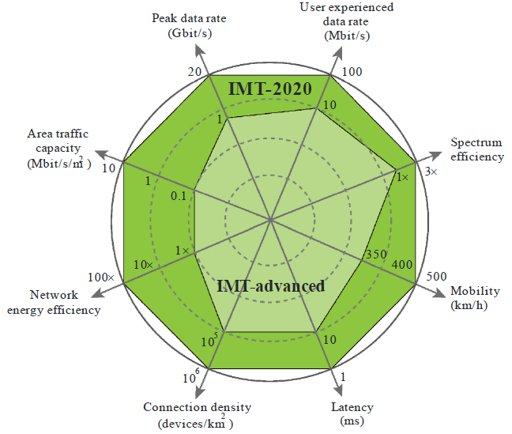
Figure 1.1 Performance comparison of IMT-advanced (4G) and IMT-2020 (5G)
maximize the network efficiency by converging other powerful RATs including IEEE 802.11 series (e.g., legacy Wi-Fi and Wi-Fi HaLow), low-power wide-area networks (LPWAN) technologies (e.g., LoRA, Sigfox, and Zigbee), and device-to-device (D2D) communications (e.g., vehicle-to-vehicle/everything, Wi-Fi direct, and dedicated short-range communications/DSRC). In recent years, the Third Generation Partnership Project (3GPP) has started to conduct the study items of non-terrestrial networks (NTN) [3], [4]. The ubiquitous communication provided by the NTN (e.g., satellites and unmanned aircraft system/UAS) makes it become a promising RAT to be comprised in multi-RATs [5]. It is plausible to envisage that the landscape of 5G network will be incorporated with diverse classes of client devices (CDs) or user equipments (UEs) and co-existence of heterogeneous RATs, as illustrated in Fig. 1.2 [6]. The PHY layer performance of co-existence of heterogeneous RATs relies on a well-designed waveform [7], which is jointly-evaluated by several key performance indicators (KPIs) of waveforms such as complexity, filter design, latency,
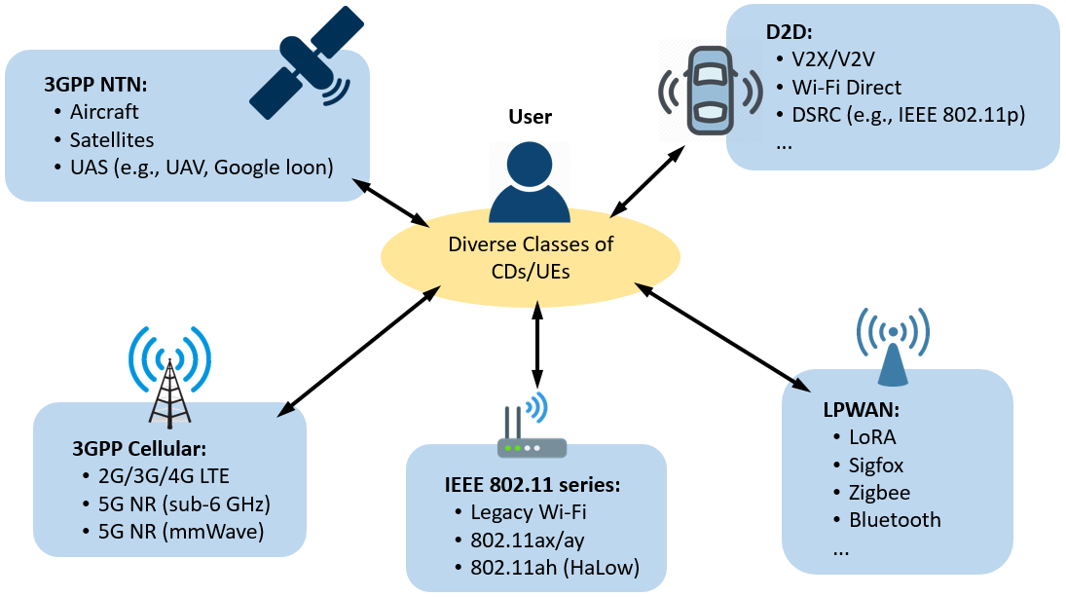
Figure 1.2 The Multi-RAT landscape in 5G
spectral efficiency (SE), spectral coexistence, power spectral density (PSD), and peak-to-average power ratio (PAPR) [8]. Many waveform candidates had been discussed before 3GPP freezes orthogonal frequency division multiplexing (OFDM) and its low-PAPR variant, discrete Fourier transform (DFT) spread OFDM (DFT-s-OFDM), as 5G waveforms, including filter-bank multicarrier (FBMC), generalized frequency division multiplexing (GFDM), universal filtered multicarrier (UFMC), windowed-OFDM (W-OFDM), and filtered-OFDM (F-OFDM) [9], [10]. However, these waveform candidates had been postponed due to their high-PAPR essence and low compatibility for Long Term Evolution (LTE) systems. The KPI of PAPR still dominates the adoption of waveform.
Except for LPWAN technologies, it can be found that most of the RATs mentioned in Fig. 1.2 (i.e., 3GPP Cellular/NTN, D2D, and IEEE 802.11 series) utilize OFDM-based waveform for uplink (UL) or downlink (DL) transmission, while they are standardized by different organizations or alliances. This is because OFDM is favored for its high spectral efficiency, low-complexity equalization, simple channel estimation, efficient hardware implementation via fast Fourier transform (FFT), and easy combination with multi-input multi-output (MIMO) transmission. In the viewpoint of multi-RATs, using consistent waveforms reduces the implementation complexity of RF and digital baseband (DBB) module owing to the reuse of hardware for different RATs.
    - PAPR Issue
However, as a multicarrier-based waveform, the high PAPR problem [11] of OFDM thus remains a long-standing implementation issue [12]–[15]. Many studies have considered how to operate the transmit power amplifier (PA) in its linear region with less input backoff (IBO) in order to be more power-efficient. Figure 1.3 describes the relationship between PAPR, IBO and PA efficiency [15]. The high PAPR signal (blue line) should be operated with high IBO to avoid saturation; the low PAPR signal (purple line) can be operated at low IBO for an exponentially increased PA efficiency. From Fig. 1.3, the IBO is defined as
$$IBO=10\log_{10}\left(\frac{P_{sat}}{P_{av}}\right) \left[dB\right]\text{, } \text{(1.1)}$$
where $P_{av}$ is the average power of input signal and $P_{sat}$ is the saturated power of
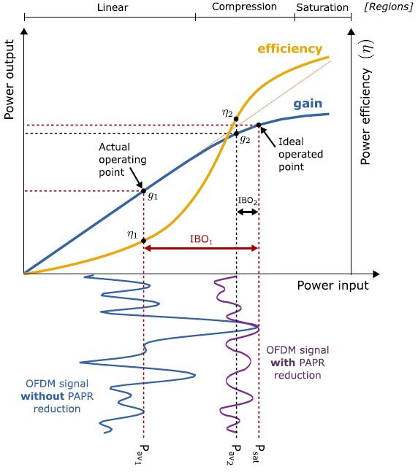
Figure 1.3 The relation between PAPR, IBO and PA efficiency.
PA. The definition is similar to PAPR, which is defined as
$$ξ=10\log_{10}\left(\frac{P_{peak}}{P_{av}}\right) \left[dB\right]\text{, } \text{(1.2)}$$
where $P_{peak}$ is the peak power of a signal. In general, $P_{peak}$ is assumed to be equal to $P_{sat}$ for outputting a linearly amplified signal. However, as the generation of OFDM signals is a random process whose PAPR distribution can be expressed by a complementary cumulative distribution function (CCDF). Figure 1.4 presents the PAPR (in dB) of CCDF for the typical OFDM signals with $N=\text{100, 1000, 10000, 100000}$ subcarriers [16]. It can be observed that the probability of an input signal ($N=\text{100}$) over 12 dB PAPR is smaller than 0.01%. Therefore, we can reasonably regard the value of PAPR as the designed IBO if 0.01% tolerance is acceptable for a system. This assumption can be used for evaluating the improvement
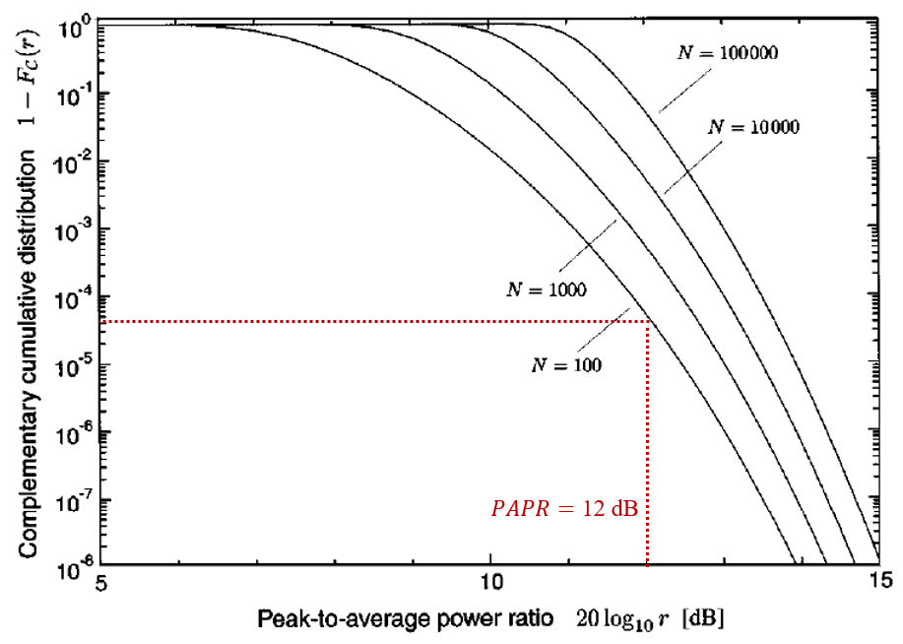
Figure 1.4 The CCDF of PAPR for OFDM signals with different number of subcarriers.
of PA efficiency. According to [17], the PA efficiency $η$ is given by
$$η=\frac{η_{max}}{PAPR}×100\% \text{, } \text{(1.3)}$$
where $η_{max}$ is the maximum efficiency of PA and $PAPR$ is the PAPR of an input signal. Throughout this dissertation, we take Class-A PA for example where its maximum output efficiency is 50% ($η_{max}=\text{0.5}$). Figure 1.5 displays the power efficiency of Class-A PA and operating points of Rapp’s model [18] for solid state PA (SSPA) (smooth factor $p=\text{2}$) with different IBOs. It can be seen that power efficiency improves when lower IBO is used; however, the signal suffers more nonlinear distortion simultaneously, resulting in serious spectral radiation and bit error rate (BER) degradation. To solve this dilemma, the PAPR reduction techniques for OFDM signals form an essential need for implementation.
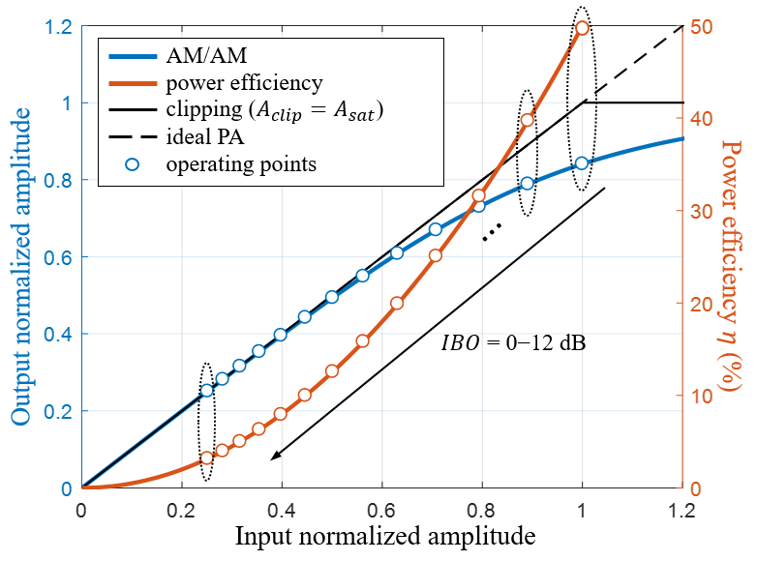
Figure 1.5 Comparison of power efficiency curve and AM/AM transfer characteristics of PA (Rapp’s model).
Furthermore, the flexibility of trade-off between PAPR reduction and other capabilities of the waveform for UL becomes a new issue in 5G owing to miscellaneous scenarios and the use of multi-RATs. To show this, Fig. 1.6 sketches the examples of RF modules that are adopted by different types of UEs for three 5G use cases. Although the variance of the capability of RF modules among these UEs is expansive, these UEs still communicate with one other based on CP-OFDM/DFT-s-OFDM, which are with fixed PAPR performances. Therefore, the strategies in dealing with PA nonlinearity for further PAPR reduction will depend on the capabilities of quality of PA. For example, the UEs used in eMBB and URLLC are usually equipped with fair-quality PAs which at least can afford the PAPR of DFT-s-OFDM signals for the macro/micro cell or CP-OFDM signals for the femto/pico cell. On the other hand, the UEs used in mMTC are usually equipped with basic PAs due to the limitation of low cost. Further PAPR reduction for both types of PA should be treated in different ways. More details of the description of the scenario where PA is used are given in the following two subsections.
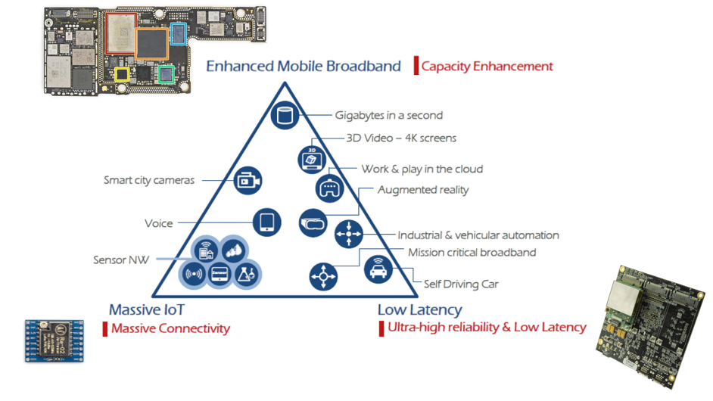
Figure 1.6 Different-quality PAs used in various 5G applications.
    - Scenarios for Reducing PAPR at Transmitter
In most cases, reducing PAPR at transmitter is a proper manner to prevent systems from spectral radiation and in-band noise. This assures the output signal can only be affected by the fading channel without the distortion before transmission. Although reducing the PAPR of the signal is an issue at both the UL and DL, it is more critical for the UL, due to the limited cost and power-budget of UEs. As usual, PAs are one of the most energy-hungry components [19], [20]. The efficient PA conversion can effectively extend the battery lifespan of UEs. Alternatively, it can significantly boost the transmission power to increase the number of cell-edge users and the signal-to-noise ratio (SNR) at the same IBO [21]. This also benefits the issue of D2D power control for proximity services (ProSe) in LTE systems [22] and efficient satellite communications for NTN [23]. Figure 1.7 illustrates the relationship between PAPR and SNR for UL and DL of satellite communications [24]. The PAPR issue occurs both in UL and DL since the spaceborne platform and handhold devices are power-limited systems as the scenario of D2D communications.
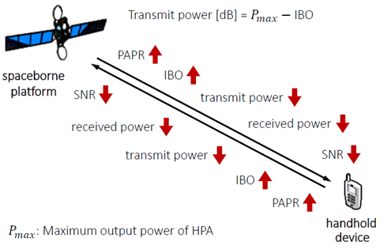
Figure 1.7 Relationship between PAPR and SNR for satellite communications.
    - Scenarios for Mitigating Nonlinearity at Receiver
In this subsection, we elaborate on the current state of LPWAN technologies and explore the reason why the manner of reducing PAPR at transmitter may not be appropriate for OFDM-based LPWAN technologies. As shown in Fig. 1.2, LPWAN technologies is also a promising multi-RAT due to the fast-pace increase of internet of things (IoT) services [25]. They aim to satisfy the needs of the machine-type communication, in both licensed and unlicensed band, that features as long-range transmission, low data rate, low cost, and low power consumption [26], [27].
SigFox and LoRa were first announced as commercial LPWAN technologies and have been widely deployed in many countries within the last decade [25]. This has triggered 3GPP and IEEE to rapidly complete the standardization of narrowband (NB)-IoT [28] and 802.11ah [29], respectively, in order to be involved with great IoT market. NB-IoT can be directly applied to Global System for Mobile Communications (GSM) or LTE system for reducing deployment costs and thus, many industries (e.g., Nokia, Ericsson, and Huawei) have spent tremendous effort in its standardization [30]. On the other hand, 802.11ah is highly compatible to the existing Wi-Fi systems due to the analogous numerology to IEEE 802.11ac, which utilizes industrial, scientific and medical (ISM) radio bands for transmission. Whether the licensed or unlicensed are concerned, both emerging LPWAN techniques are quite competitive due to their deployment superiority [29].
However, the high power consumption issue impacts the commercialization of NB-IoT and 802.11ah applications [31], as they are based on OFDM that usually leads to power-inefficiency [32], [33]. This is due to the high PAPR signal that lowers the efficiency of the PA [14], which is one of the most energy-hungry components of UE, especially in IoT. To solve this dilemma, NB-IoT allows single-carrier transmission, utilizes DFT-s-OFDM as uplink waveform, and restricts the number of subcarriers less than than 12 (1 Physical Resource Block, PRB) for multi-carrier transmission [34].
As for 802.11ah, most of the power saving methods in literature were proposed in circuit level (e.g., [35]–[37]) or medium access control (MAC) level (e.g., [38]–[41]), while the system-level method is still under-researched and under-discussed. The only exception is found in [42] that considers the scenario of a low-cost low-power transmitter (IoT-based UE, IoT-UE) communicating with a high-quality receiver (access point, AP). By compensating for the nonlinearity of received signals at powerful AP, the IBO of UE’s PA can be minimized, as subject to the spectral mask and channel quality [43]. Such a solution may become a strategy for IoT-UE power saving according to the following reasons:
- Intermittency of MTC in 5G wireless systems. According to the 5G used cases described by the ITU [1], i.e., eMBB, URLLC, and mMTC, the receiver-side compensation methods cannot be suitably applied in the first two scenarios except the last. As MTC acts as a delay-tolerance service, almost all LPWA technologies allow a long duration of idle/sleep mode for power saving. The burst traffic nature caused by the event-driven wireless sensor networks (WSN) [44] brings a considerable time margin for performing the iterative computations at the receiver/AP.
- UL-dominated MTC traffic highlights the problem of OFDM nonlinearity on the IoT-UE. For eMBB and URLLC, the DL traffic is much heavier than UL so that the nonlinearity issue can be well-managed at the AP. While most current MTC applications are utilized for IoT data gathering that makes the throughput in IoT networks UL-dominated [45], the main problem of signal linearization occurs at the IoT-UE owing to its basic PA.
- Concerns of low cost and low power consumption for IoT-UE push the nonlinearity issue toward the consideration of receiver-oriented solutions. Compared with the IoT-UE, the AP (access point) owns much more sufficient computational resources (e.g., power supply, hardware quality, and processing time). As the cost and battery-lifetime of IoT-UE dictate the business model of IoT applications, it is reasonable to transfer the processing efforts from the IoT-UE to the AP by applying the receiver-oriented signal linearization methods at AP. Indeed, all receiver-oriented methods must face the problem of fading channel and its estimation [46] which dominates the performance of the signal recovery. However, the channel condition in the MTC may be relatively more stable than the other two 5G used cases (i.e., eMBB and URLLC), due to its zero or limited mobility [47].
On the other hand, the 802.11ah is famous for its high transmit efficiency in kbits/mJ [32]. As plotted in Fig. 1.8, it can be seen that 802.11ah outperforms most of popular LPWAN technologies except the conventional Wi-Fi within 20 meters of
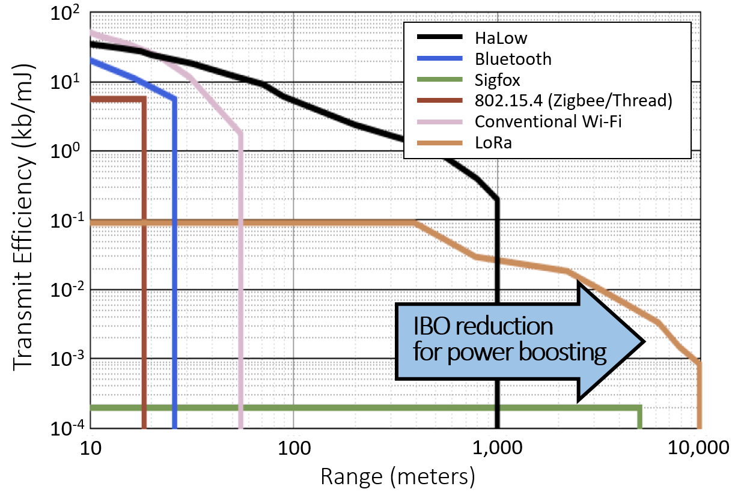
Figure 1.8 Comparison of transmit efficiency of different LPWAN technologies.
transmit range [48]. However, the OFDM signals used by 802.11ah UL cannot transmit over 1 km because of the low transmit power for link budget. Compensating the nonlinear distorted signal at AP seems to be a potential method for further reduction of IBO, thus IoT-UEs can boost the transmit power of PA and extend the signal coverage.
  - Literature Review

    - Taxonomy of Solutions for PAPR Issue
Figure 1.9 shows the baseband system block diagram of a typical OFDM transmitter and four categories of the solution to addressing the PAPR issue: coding, multiple signaling and probabilistic (MSP), signal distortion, and PA linearization [15], [49]. Coding and MSP can reduce the signal’s PAPR without signal distortion. They aim to decrease the probability of peak overlapping among subcarriers with the cost of additional computations for searching/acquiring minimum/subminimum PAPR signals and additional bandwidth for transmitting the side information (some of MSP schemes). Although signal distortion methods can lessen the signal’s PAPR
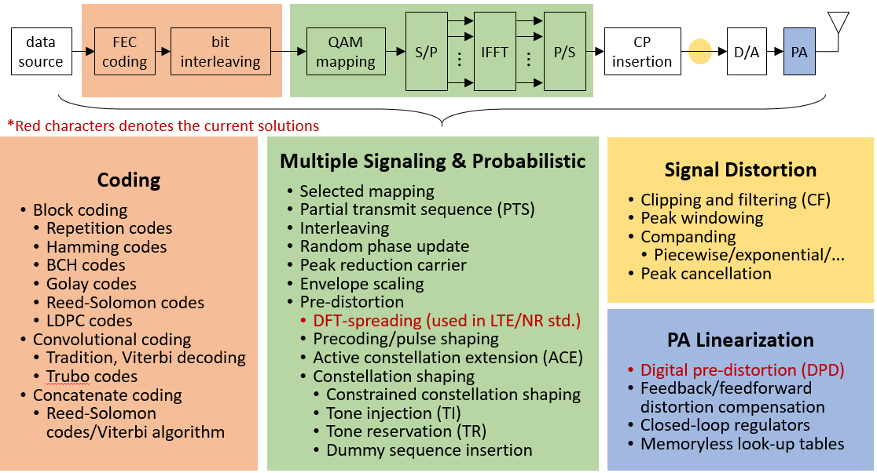
Figure 1.9 Taxonomy of solutions for PAPR issue.
with lower computational complexity, the adverse effect of nonlinear processing severely degrades the system performances. PA linearization techniques such as digital pre-distortion (DPD) tend to be a fundamental component in current and next-generation wireless communication systems. It increases the linear region of PA (see Fig. 1.3) that allows the signals can be transmitted with lower IBO. However, the use of DPD needs extra processing for signal linearization and thus increases the computational complexity of PA. In general, it is more likely to standardize coding and MSP in the protocols because both methods can be easily implemented in the system level. On the other hand, signal distortion and PA linearization cannot be appropriately standardized since the specified parameters depend on the hardware design of each product of each brand.
So far only two schemes have been agreed upon as standard solutions for 4G LTE and 5G NR (New Radio) uplink signaling [50], [51]. The first standard solution, DFT-s-OFDM (i.e., DFT-spreading in Fig. 1.9), which is also known as single-carrier frequency-division multiple access (SC-FDMA), appeared in 2006 [52]. It was used to conduct relatively low-PAPR signaling by only reusing the chip-built-in DFT module in user equipment. The second solution is rotated modulation, including ${\text{π}}/{\text{2}}$-binary phase shift keying (${\text{π}}/{\text{2}}$-BPSK) and π⁄4-quadrature PSK (${\text{π}}/{\text{4}}$-QPSK), which were originally adopted for NB-IoT mono-tone transmissions since Rel-13 [53]. Apart from the QPSK and quadrature amplitude modulations (QAMs), ${\text{π}}/{\text{2}}$-BPSK has been a part of the available modulations of the DFT-s-OFDM uplink since Rel-15 [51]. The ${\text{π}}/{\text{2}}$-BPSK and ${\text{π}}/{\text{4}}$-QPSK perform identically in terms of errors to BPSK and QPSK, but reduce the PAPR without any increase in computational complexity, making it highly compatible with the current waveforms. Denote that the rotated modulation only works in DFT-s-OFDM, and thereby does not need to be listed in Fig. 1.9.
    - PAPR Reduction Technologies for DFT-s-OFDM
As DFT-s-OFDM is the waveform standardized in LTE/NR systems for the PAPR issue, we focus the PAPR reduction schemes which are based on DFT-s-OFDM. In recent years, enhancing the performance of DFT-s-OFDM has been discussed in 3GPP meetings since DFT-s-OFDM is expected to be a more robust waveform for UL/sidelink (SL) through adjustable PAPR reduction schemes [54]–[57]. Unlike to CP-OFDM, DFT-s-OFDM is basically a single-carrier waveform [58]. Its PAPR is highly correlated to the use of constellation and spectral shaping (SS) function.
Constellation shaping techniques can be categorized into two types: geometric [59] and probabilistic shaping [60]. The former optimizes the distance between the signal constellation points and the latter changes the probability distribution of the constellation points to approach Gaussian distribution. Although recent works on constellation shaping for LTE/NR have been expressed in broad discussion [61], [62], the 3GPP only introduces the rotated modulation to LTE/NR protocols due to the backward compatibility [50], [51].
The SS are data-independent schemes [63] to use extra subcarriers to further reduce PAPR without BER degradation. The 3GPP had considered several modified architectures of DFT-s-OFDM with SS schemes (also called frequency-domain spectrum shaping, FDSS) [55]. The combination of rotated modulation and typical SS schemes such as root-raised-cosine filter (RRC) and truncated RRC filter have been also evaluated and discussed to overcome the need for a flexible countermeasure to the PAPR issue [64]. In [65], Hsu and Liao proposed generalized precoding (GPC) scheme to construct many famous precoding transforms, such as DFT [52], discrete Hartley transform [66], and Zadoff-Chu transform [67], into a scalable form consisted of periodically extended transform matrix and spectrum shaping function. Although GPC increases much flexibility of the trade-off between further PAPR reduction and spectral efficiency of DFT-s-OFDM, consideration of the actual specifications and ability of PAPR reduction remains open for improvement.
    - Nonlinear Noise Mitigation Technologies for OFDM
There are numerous studies in literature on the receiver-side compensation methods which can be categorized into two types: maximum-likelihood (ML) detection-based (e.g., [68]–[70]) and signal compensation (SC)-based (e.g., [71]–[75]). The former is a specification transparent approach and can achieve a better BER performance than the latter due to the exhaustive search, but its computational complexity grows exponentially with the fast Fourier transform (FFT) size that leads to infeasibility. As for the SC schemes, they usually are developed with an assumption that the transmitted signals are transferred by a known process for PAPR reduction (e.g., clipping and companding). Therefore, the nonlinear noise can be estimated and cancelled at the receiver. Although those reported SC schemes require significantly less computation effort, to the best of our knowledge, all of them take the data-subcarrier-only signal model which is far from any real-world specification/standard. Note that the actual OFDM system contains non-data type of subcarrier such as pilot and null subcarriers, and the use of data-subcarrier-only signal model would impair the precision of nonlinear noise estimation and cancellation.
  - Organization of Dissertation
The rest of this dissertation is organized as follows. In Chapter 2, the used system model of OFDM with PA nonlinearity and fading channel are described. In Chapter 3, we present two transmitter-side techniques, improved GPC [76] and polynomial cancellation coded (PCC)-DFT-s-OFDM [77] including its bit-level implementation for transmitters [78], to reduce the undesirable effect of PA nonlinearity in a flexible and LTE/NR-compatible manner. A novel SC scheme, iterative subcarrier regularization (ISR), to mitigate the nonlinear noise at 802.11ah AP in the LPWAN scenario is introduced in Chapter 4, which is followed by the concluding remarks.

SYSTEM MODEL
  - OFDM Transceiver
The block diagram of baseband system model for OFDM transceiver with optional functions of transform precoding (used in Chapter 3) and SC schemes (used in Chapter 4) is schematized in Fig. 2.1. Let ${X=\left[X_{0}, …, X_{N-1}\right]}^{T}$ denote the subcarrier vector that carries $N_{d}$ symbol data, $N_{p}$ pilot data and $N_{n}$ null data (including guard band and DC), where the symbol data comes from modulated symbol vector ${s=\left[s_{0}, …, s_{M-1}\right]}^{T}$ or transform-precoded symbol vector ${S=\left[S_{0}, …, S_{N_{d}-1}\right]}^{T}$ ($M≤N_{d}$). The time-domain OFDM symbol vector can be generated by ${x≜\left[x_{0}, …, x_{N-1}\right]}^{T}=F_{N}^{H}X$, where $F_{N}$ is the $N$-by-$N$ DFT matrix whose entry is given by
$${\left[F_{N}\right]}_{(n, k)}=\frac{1}{\sqrt{N}}e^{-j\left(\frac{2π}{N}\right)nk}\text{, }0≤n\text{, }k≤N-1.$$ | (2.1)
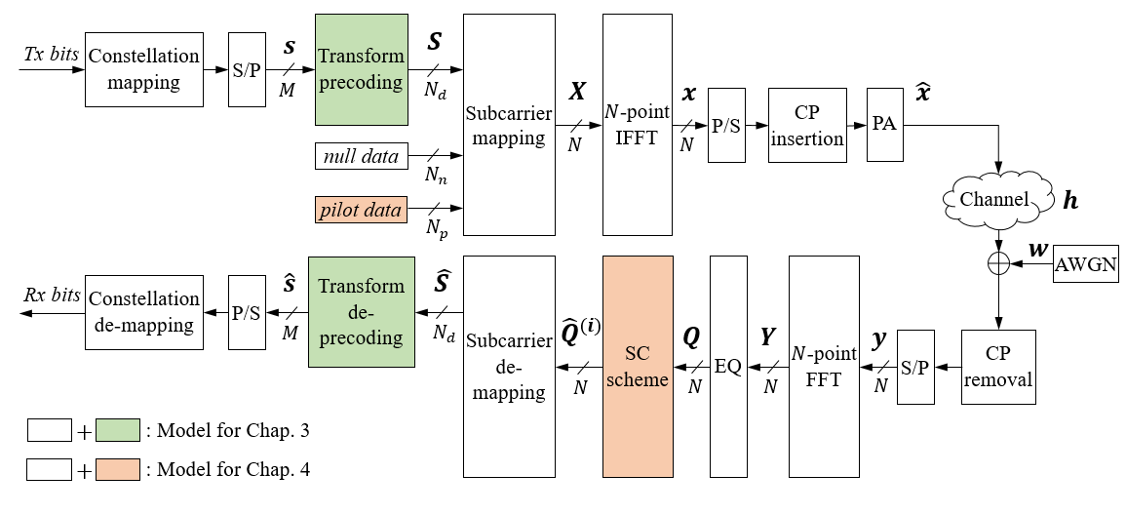
Figure 2.1 Block diagram of baseband OFDM system model.
A cyclic prefix (CP) with length $P$ is inserted into $x$ to mitigate the inter-symbol interference, yielding ${\left[x_{N-P}, …, x_{N-1}, x_{0}, …,x_{N-1}\right]}^{T}$. Considering a popular PA nonlinearity model, the Rapp model [18], the transmitted sequence can be expressed as
$\hat{x}=G\left(x\right)=g∙x{\left[1+{\left(\frac{g∙\left|x\right|}{A_{sat}}\right)}^{2p}\right]}^{-\frac{1}{2p}}$, | (2.2)
where $A_{sat}$ is the PA saturation level specified by the value of IBO (in dB) from $A_{sat}=x_{RMS}∙{10}^{{IBO}/{20}}$, $x_{RMS}=\sqrt{{\sum_{n=0}^{N-1}{{\left|x_{n}\right|}^{2}}}/N}$, $p$ is the smoothness factor, and $g$ is the amplifier voltage gain. Here, we consider a unitary gain ($g=\text{1}$) for simplicity and generality and a severe nonlinearity ($p=\text{2}$) for simulating low-complexity PAs.
Assuming a perfect synchronization and channel estimation, the received samples over the Rayleigh fading channel and after CP removal is given by
$y=h⊛_{N}\hat{x}+w$, | (2.3)
where $h={\left[h_{0}, …, h_{L-1}\right]}^{T}$ is the $L$-tap channel impulse response ($L≤P$), $⊛_{N}$ is the circular convolution operator with length $N$, and $w={\left[w_{0}, …, w_{N-1}\right]}^{T}$ is an additive white Gaussian noise (AWGN) vector whose elements follow $w_{n}∼CN\left(0\text{,} σ^{2}\right)$. Thus, we have the received subcarrier data vector:
$Y=H\hat{X}+W$, | (2.4)
where $H=diag\left\{{F_{N}h}^{0}\right\}$ is the channel frequency response, $h^{0}={\left[h, 0, …, 0\right]}^{T}$ is the zero-padded $h$ with length $N$, and $Y$, $\hat{X}$ and $W$ are the DFT of $y$, $\hat{x}$ and $w$, respectively. From Eq. (2.4), the equalized subcarrier data vector can be written as
$Q=YH^{-1}=H\hat{X}H^{-1}+WH^{-1}$. | (2.5)
Here, an optional function that employs an SC scheme on $Q$ for a better result of QAM demodulation, resulting in the $i$ iteration-restored subcarrier data vector ${\hat{Q}}^{\left(i\right)}={\left[{\hat{Q}}_{0}^{\left(i\right)}, …, {\hat{Q}}_{N-1}^{\left(i\right)}\right]}^{T}$.

2.2 CCDF of PAPR
For any stochastic complex signal $x=\left[x_{0}, …,x_{N-1} \right]$, its performance of the PAPR $ξ$ in terms of CCDF can be presented as:
$$CCDF\left(ξ_{0}\right)=Pr\left(ξ>ξ_{0}\right)\text{,} ξ≜\frac{\max_{0≤n≤N-1}{{\left|x_{n}\right|}^{2}}}{E\left\{{\left|x_{n}\right|}^{2}\right\}}\text{,}$$ | (2.6)
where $E\left\{•\right\}$ is the expectation operator.

2.3 Single-Carrier Representation of DFT-s-OFDM
In this section, we demonstrate a DFT-s-OFDM system can be analytically represented in the form of a single carrier, which is consisted of modulated symbols and pulse shaping. For the LTE/NR compatibility, we focus on a localized FDMA system [52].
The PSK/QAM symbols ($s_{m}$) are linearly precoded by an $N_{d}$-point DFT to result in the frequency-domain data $X_{k}$:
$$X_{k}=\frac{1}{\sqrt{N_{d}}}\sum_{m=0}^{N_{d}-1}{s_{m}W_{N_{d}}^{km}}\text{,} 0≤k≤N_{d}-1\text{,}$$ | (2.7)
where $W_{N_{d}}=e^{-j\left(\frac{2π}{N_{d}}\right)}$ is the twiddle factor. After being zero-padded and after the$N$-point inverse DFT (IDFT) of $X_{k}$ is taken, the transmitted signal samples $x_{n}$ can be written as [79]:
$$x_{n}=\frac{1}{\sqrt{N}}\sum_{k=0}^{N_{d}-1}{X_{k}W_{N}^{-kn}}$$  $$=\frac{1}{\sqrt{N_{d}N}}\sum_{k=0}^{N_{d}-1}{\sum_{m=0}^{N_{d}-1}{s_{m}W_{N_{d}}^{km}}W_{N}^{-kn}}$$  $$=\frac{1}{\sqrt{N_{d}}}\sum_{m=0}^{N_{d}-1}{s_{m}g\left[n-\frac{N}{N_{d}}m\right]}\text{,} 0≤n≤N-1\text{,}$$ | (2.8)
where
$$g\left[n\right]=\frac{sin\left(\frac{N_{d}πn}{N}\right)}{\sqrt{N}sin\left(\frac{πn}{N}\right)}e^{j\frac{(N_{d}-1)πn}{N}}.$$ | (2.9)

NONLINEARITY MITIGATION AT TRANSMITTERS

  - Improved Generalized Precoding (GPC)
    - Conventional GPC
The conventional GPC [65] generalizes the precoding techniques for PAPR reduction as a matrix $P_{GPC}$ which is consisted of an $N_{d}×N_{d}$ diagonal matrix $G$ for SS and an $N_{d}×M$ periodic extended transform matrix $\tilde{U}$:
$P_{GPC}=G\tilde{U}=diag\left[G_{i}\right]\left[U_{i,j}\right]\text{,} 0≤i≤N_{d}-1\text{,} 0≤j≤M-1$, | (3.1)
where
$G_{i}=\left\{\begin{aligned}\frac{{(-1)}^{i}}{\sqrt{M}}\sin\left(\frac{πi}{2ΔN_{d}}\right) \text{, }0≤i≤ΔN_{d}-1 \\ \frac{{(-1)}^{i}}{\sqrt{M}} \text{,} ΔN_{d}≤i≤M-1 \\ \frac{{(-1)}^{i}}{\sqrt{M}}\cos\left[\frac{π\left(i-M\right)}{2ΔN_{d}}\right] \text{,}M≤i≤N_{d}-1 \end{aligned}\right.$ , | (3.2)
and
$U_{i,j}=e^{-j\left(\frac{2π}{M}\right)\left(i mod M\right)j}$, | (3.3)
where $mod$ is the modulo operator and $ΔN_{d}$ represent the number of redundant input symbols by $ΔN_{d}=N_{d}-M$ ($N_{d}≥M$). Therefore, the GPC precoded symbol vector $S$ and de-precoded symbol vector $\hat{s}$ can be yielded by
$S=P_{GPC}s$, | (3.4)
and
$\hat{s}=P_{GPC}^{-1}\hat{S}$, | (3.5)
respectively, where $P_{GPC}^{-1}=P_{GPC}^{H}$. From Eq. (3.2), it shows that GPC reduces the PAPR with additional $ΔN_{d}$ subcarriers, which are reserved from 0–12 guard subcarriers in [65] with 802.11a parameterization ($N=\text{64}$, $M=\text{52}$, $0≤ΔN_{d}≤M-N=\text{12}$).
    - Proposed GPC Structure
GPC develops a flexible architecture for PAPR reduction by occupying adjustable $ΔN_{d}$ guard subcarriers for the 802.11a transmission. However, such an application may not be feasible because currently the 802.11 series do not adopt any system-level PAPR reduction technique in the standard and the use of additional guard subcarriers may increase the adjacent channel leakage ratio (ACLR) that makes PSD performance exceeds the spectral mask. As a result, we proposed a modified version of GPC which can be deployed on the current LTE/NR standard as they allow DFT-s-OFDM signalling (precoding-based OFDM). Moreover, we also modify the conventional GPC by prefix-based precoding instead of postfix-based one, so that GPC can achieve further improve the PAPR reduction without any increase of computational complexity [76], [80].
      - GPC Coding Rate
From Eq. (3.2), $M$-input PSK/QAM data will be precoded and extended to $N_{d}$-output OFDM data symbols for subcarrier mapping. An adjustable parameter $γ$, named GPC coding rate, is defined for controlling the trade-off between further PAPR reduction and transmission rate, as
$$γ=\frac{M}{N_{d}}=\frac{N_{d}-ΔN_{d}}{N_{d}}=1-\frac{ΔN_{d}}{N_{d}} .$$ | (3.6)
Note that the current LTE/NR UL, DFT-s-OFDM, uses $ΔN_{d}=\text{0}$ ($γ=\text{1}$) for rate-lossless transmission which can be a special case in GPC.
      - Prefix and Postfix DFT Precoding
In conventional GPC, the postfix precoding, i.e, Eq. (3.3), is used for reducing the PAPR of OFDM signals. As the contribution of PAPR reduction is almost gained form $\tilde{U}$ where $G$ only maintains the energy between input and output symbols, we still can reselect and reposition the $N_{p}$ duplicates of $U$ elements to improve the diversity of signal phase for further PAPR reduction without increasing any computational complexity. Consequently, an improved version of elements for $\tilde{U}$ in Eq. (3.3) is proposed, as
$$U_{i,j}=e^{-j\left(\frac{2π}{M}\right) \left(\left(i-ΔN_{d}\right) mod M\right)j} \text{.}$$ | (3.7)
Note that this modification reorders the precoded symbols with keeping the periodicity of $\tilde{U}$ where $G_{i}$ is still consistent with Eq. (3.2). To show the improvement of diversity of the signal phase for prefix-based precoding, the difference of subcarriers whose phase has been changed in postfix- and prefix-based precoding is illustrated in Fig. 3.1.
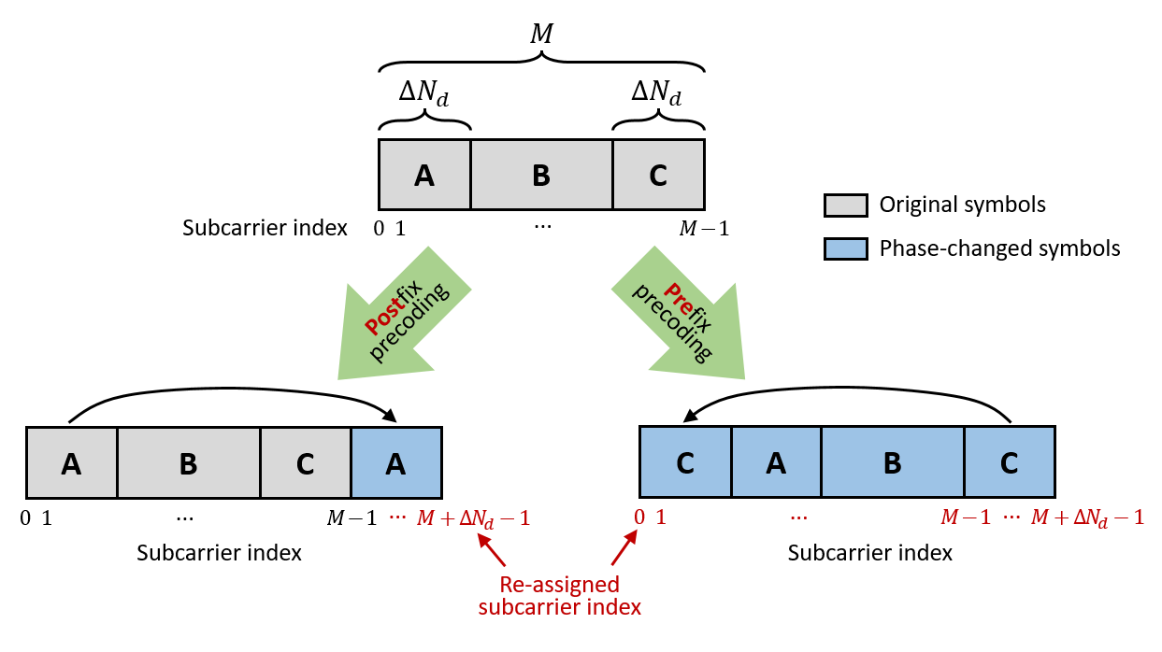
Figure 3.1 Illustration of the phased-changed symbols of postfix-based and prefix-based precoding.
    - Numerical Results
Simulation results are presented for the proposed improved GPC scheme over LTE/NR standards [50], [51] as a paradigm (system parameterization refer to Table 3.1). Figure 3.2 to 3.3 presents the PAPR performance of original and improved GPC at $γ=\text{0.8, 0.9, 1}$ with BPSK and QPSK modulation respectively. Note that the PAPR performance of GPC at $γ=\text{1}$ is consisted with conventional DFT-s-OFDM.
Table 3.1 Simulated system parameterization for improved GPC (LTE/NR).
Channel  Bandwidth | #RB | $$N_{d}$$ | $$N_{n}$$ | $$N$$ | $$γ$$ | Modulation
1.4 MHz | 6 | 72 | 56 | 128 | 0.5 – 1 | BPSK  QPSK  16-QAM  64-QAM  256-QAM
5 MHz | 25 | 300 | 212 | 512 | 0.5 – 1 | BPSK  QPSK  16-QAM  64-QAM  256-QAM
10 MHz | 50 | 600 | 424 | 1024 | 0.5 – 1 | BPSK  QPSK  16-QAM  64-QAM  256-QAM
20 MHz | 100 | 1200 | 848 | 2048 | 0.5 – 1 | BPSK  QPSK  16-QAM  64-QAM  256-QAM
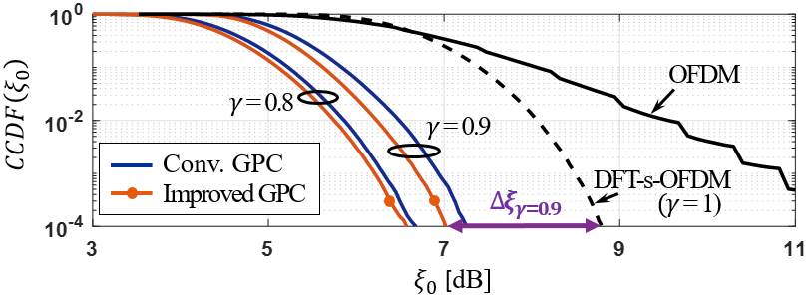
Figure 3.2 CCDF comparison of PAPR (Channel BW=1.4MHz, BPSK).
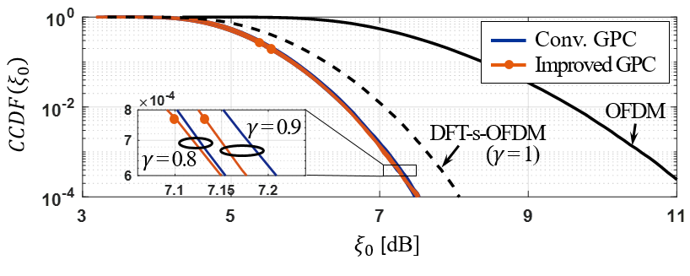
Figure 3.3 CCDF comparison of PAPR (Channel BW=1.4MHz, QPSK).
As shown in Fig. 3.2, GPC significantly reduces the signal PAPR for 1.5–2 dB in BPSK modulation compared with conventional DFT-s-OFDM, where the proposed scheme performs a better PAPR reduction. From the results in Fig. 3.3, it can be seen that the improvement of PAPR reduction decreases in QPSK. To figure out the overall trade-off between this improvement and transmission rate, we calculate the deviation of PAPR reduction according to $γ=\text{1}$ at $CCDF={\text{10}}^{\text{-4}}$ for $γ=\text{0.5–1}$, defined as ${∆ξ}_{γ}=ξ_{γ=1}-ξ_{γ}$, over different QAM orders (refer to Fig. 3.4) and channel bandwidths (refer to Fig. 3.5), respectively. As observed in Fig. 3.4, there is a clear trend that the improvement of PAPR reduction (i.e.,${∆ξ}_{γ}$) is negatively related to the QAM order. This trend is not evident for 16- to 256-QAM since the increase of signal
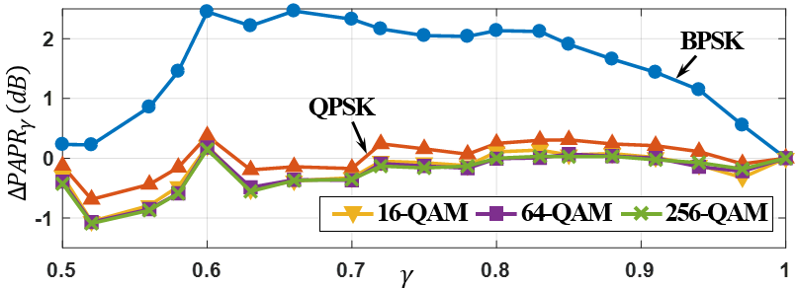
Figure 3.4 Improvement of PAPR reduction in different GPC coding rate and QAM order for proposed algorithm. (Channel BW=1.4MHz).
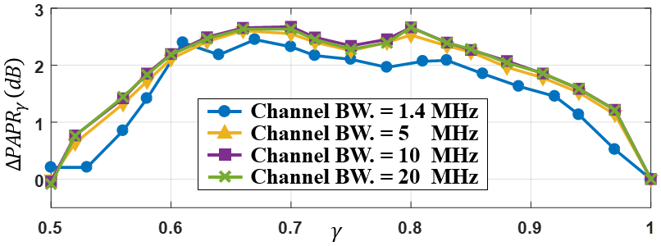
Figure 3.5 Improvement of PAPR reduction in different GPC coding rate and channel bandwidth for proposed algorithm (BPSK).
phase diversity saturates in high-order QAM. However, this finding can be suitably applied in mMTC and uRLLC as the scenario of low transmission rate, low power consumption (efficiency improvement), and low cost (low-complexity PA). On the other hand, Fig. 3.5 illustrates the $∆ξ$ performance at certain $γ$ can be scaled to the other channel bandwidth. This characteristic benefits the stability of communication systems on switching the transmission bandwidth.
    - Discussion
As 5G NR the DFT-s-OFDM needs to be more flexible for supporting different-quality PAs on various 5G devices. In this section, we redesign the parameters for original GPC and make it compatible with specifications to facilitate its flexibility of PAPR reduction. Moreover, we improve the original GPC for DFT-s-OFDM with a better PAPR reduction without any increase of computational complexity by the rearranging the periodic-padding for precoded data symbols in the GPC precoding matrix. The LTE/NR-based simulation results show the proposed method has a better improvement of PAPR reduction especially in low-order modulations and the performances can be scaled to the different transmission bandwidth. These findings make the proposed algorithm more practical for use.
However, it can be found that the GPC achieves 2–3 dB PAPR reduction compared with conventional DFT-s-OFDM with 10%–20% spectral efficiency loss, further spectral efficiency loss does not improve the PAPR performance more, and instead degrades it. In the next section, we will introduce a novel adjustable precoding technique to acquire further PAPR reduction with consuming more spectral efficiency.

  - Polynomial Cancellation Coded (PCC)-DFT-s-OFDM
A long-established OFDM-based waveform, polynomial cancellation coding (PCC)-OFDM [81], is developed for reducing the out-of-band (OOB) interference between users. The PCC applied in PCC-OFDM is treated as a frequency coding technique for OFDM that maps the data onto weighted groups of subcarriers. With this simple preprocessing, the differential operation in the time domain benefits PCC-OFDM on the performance of frequency localization, and the immunity of frequency offset and Doppler spread, making it one of the waveform candidates for 5G and beyond [82]. As taking PCC in the data domain can shape the components in the transformed domain, this inspires us to utilize PCC as a novel SS scheme to reduce the PAPR of DFT-s-OFDM signals.
    - PCC Mapping/Demapping
The $d$-order PCC mapping matrix $P$ is an $N_{d}$-by-$M$ matrix [77] whose entries are zeros except $P\left(2^{d}m\text{, }m\right)={\left(-1\right)}^{u}\text{, …,} P\left(2^{d}m+u\text{, }m\right)={\left(-1\right)}^{u}$ for $0≤m≤N_{d}-1$ and $0≤u≤2^{d}-1$, where $N_{d}=2^{d}M$. For example,
$P_{d=0 (N_{d}=M)}={\left[\begin{matrix}1 & 0 & ⋯ & 0 \\ 0 & 1 & ⋯ & 0 \\ ⋮ & ⋮ & ⋱ & ⋮ \\ 0 & 0 & ⋯ & 1\end{matrix}\right]}_{M×M}=I_{M}$ , | (3.8)
$P_{d=1 (N_{d}=2M)}={\left[\begin{matrix}1 & 0 & ⋯ & 0 \\ -1 & 0 & ⋯ & 0 \\ 0 & 1 & ⋯ & 0 \\ 0 & -1 & ⋯ & 0 \\ ⋮ & ⋮ & ⋱ & ⋮ \\ 0 & 0 & ⋯ & 1 \\ 0 & 0 & ⋯ & -1\end{matrix}\right]}_{2M×M}$, | (3.9)
and
$P_{d=2 (N_{d}=4M)}={\left[\begin{matrix}1 & 0 & ⋯ & 0 \\ -1 & 0 & ⋯ & 0 \\ 1 & 0 & ⋯ & 0 \\ -1 & 0 & ⋯ & 0 \\ 0 & 1 & ⋯ & 0 \\ 0 & -1 & ⋯ & 0 \\ 0 & 1 & ⋯ & 0 \\ 0 & -1 & ⋯ & 0 \\ ⋮ & ⋮ & ⋱ & ⋮ \\ 0 & 0 & ⋯ & 1 \\ 0 & 0 & ⋯ & -1 \\ 0 & 0 & ⋯ & 1 \\ 0 & 0 & ⋯ & -1\end{matrix}\right]}_{4M×M}$. | (3.10)
Accordingly, their PCC demapping matrices can be yielded by taking a Moore-Penrose inverse (denote as $P^{†}$). For example,
$P_{d=0 (N_{d}=M)}^{†}={\left[\begin{matrix}1 & 0 & ⋯ & 0 \\ 0 & 1 & ⋯ & 0 \\ ⋮ & ⋮ & ⋱ & ⋮ \\ 0 & 0 & ⋯ & 1\end{matrix}\right]}_{M×M}=I_{M}$ , | (3.8)
$P_{d=1 (N_{d}=2M)}^{†}={\left[\begin{matrix}1 & -1 & 0 & 0 & ⋯ & 0 & 0 \\ 0 & 0 & 1 & -1 & ⋯ & 0 & 0 \\ ⋮ & ⋮ & ⋮ & ⋮ & ⋱ & ⋮ & ⋮ \\ 0 & 0 & 0 & 0 & ⋯ & 1 & -1\end{matrix}\right]}_{M×2M}$, | (3.9)
and
$P_{d=2 (N_{d}=4M)}^{†}={\left[\begin{matrix}1 & -1 & 1 & -1 & 0 & 0 & 0 & 0 & ⋯ & 0 & 0 & 0 & 0 \\ 0 & 0 & 0 & 0 & 1 & -1 & 1 & -1 & ⋯ & 0 & 0 & 0 & 0 \\ ⋮ & ⋮ & ⋮ & ⋮ & ⋮ & ⋮ & ⋮ & ⋮ & ⋱ & ⋮ & ⋮ & ⋮ & ⋮ \\ 0 & 0 & 0 & 0 & 0 & 0 & 0 & 0 & ⋯ & 1 & -1 & 1 & -1\end{matrix}\right]}_{M×4M}$. | (3.10)
    - Proposed Method
In [77], the PCC is applied on DFT-s-OFDM, i.e., PCC-DFT-s-OFDM (refer to Fig. 3.6), for improving the PAPR performance in a more flexible manner. The PCC-based transform precoding $P_{PCC}$ and de-precoding matrix $P_{PCC}^{-1}$ are defined by
$P_{PCC}= F_{N_{d}}P$, | (3.11)
and
$P_{PCC}^{-1}= F_{N_{d}}^{H}P^{†}$, | (3.12)
respectively. Therefore, the PCC-based transform precoded symbol vector $S$ and de-precoded symbol vector $\hat{s}$ can be yielded by
$S=P_{PCC}s$, | (3.13)
and
$\hat{s}=P_{PCC}^{-1}\hat{S}$, | (3.14)
respectively. From Eqs. (3.11) and (3.12), it shows that PCC-based transform precoding needs $N_{d}$-point DFT while GPC only needs $M$-point DFT; however, in Section 3.2.3.2, we will show that the PCC-based transform precoding can be also transferred to the form of GPC, result in complexity reduction as $M$-point DFT.
    - Analysis of PAPR Reduction
      - Time-Domain Aspect
Applying the moving average to the output of OFDM at transmitters is a simple and effective method for reducing the envelope fluctuation of OFDM signals (e.g., [83]). However, similar to other time-domain-oriented schemes, this causes severe inter-carrier-interference (ICI) and out-of-band radiation that degrades the performance of the BER and causes an adjacent channel leakage ratio due to the loss of orthogonality. In other words, a typical moving average is an exceptionally good smoothing filter, but a remarkably poor low-pass filter. Despite this, PCC-DFT-s-OFDM can be introduced as a moving average-like technique while maintaining well frequency localization owing to its differential property [82]. To demonstrate this innovation in the time domain, we substituted the $d$-order PCC-mapped symbols, i.e., $\left\{Ps\right\}={\left\{{s_{\left\lfloor m/{2^{d}}\right\rfloor }∙\left(-1\right)}^{m mod 2^{d}}\right\}}_{m=0}^{N_{d}-1}$, into Eq. (2.8) and obtained the following equation:
$$x_{n}=\frac{1}{\sqrt{N_{d}}}\sum_{m=0}^{N_{d}-1}{\left({s_{\left\lfloor m/{2^{d}}\right\rfloor }∙\left(-1\right)}^{m mod 2^{d}}\right)g\left[n-\frac{N}{N_{d}}m\right]}$$  $$=\frac{1}{\sqrt{N_{d}}}\sum_{r=0}^{M-1}{s_{r}∙\sum_{u=0}^{2^{d}-1}{{\left(-1\right)}^{u}g\left[n-\frac{N}{N_{d}}\left(2^{d}r+u\right)\right]}}$$  $$=\frac{1}{\sqrt{N_{d}}}\sum_{r=0}^{M-1}{s_{r}}∙g_{n,r}^{d}\text{, }0≤n≤N-1\text{,} 0≤r≤M-1\text{,}$$ | (3.15)
where $g_{n,r}^{d}≜\sum_{u=0}^{2^{d}-1}{{\left(-1\right)}^{u}g\left[n-\frac{N}{N_{d}}\left(2^{d}r+u\right)\right]}$ is the transform of the filter, and $g\left[n\right]$ still follows Eq. (2.9). Thus, it is clear that PCC-DFT-s-OFDM is a symbol set filtered by a $2^{d}$-tap smoothing filter.
Typical moving average filters are optimized to reduce random noise while retaining the sharpness of a step response. Hence, applying moving average filters to the PSK symbols would reduce PAPR more effectively when compared with using QAM symbols because of their constant envelope. The longer filter length and more rapid spatial roll-off of the former would result in a smoother (i.e., lower-PAPR) output signal. Figure 3.6 plots the example transforms of $g_{n,r}^{d}$ with $N=\text{512}$, $N_{d}=\text{48}$, and $d=\text{0, 1, 2, 3}$. As seen in Fig. 3.6a and b, the transform of the conventional DFT-s-OFDM ($g_{n,r}^{0}$) is a sinc-like function with a narrow main lobe and small roll-off. Fig. 3.6c to h illustrate the transform of PCC-DFT-s-OFDM with different values of $d$. It can be seen that an increasing $d$ widens the main lobe and concurrently suppresses the side lobe, exhibiting a desirable moving average filter.
(a) | (b)
(c) | (d)
(e) | (f)
(g) | (h)
Figure 3.6 Example transforms $g_{n,r}^{d}$ with $N=\text{512}$ and $N_{d}=\text{48}$ for (a, b) $d=\text{0}$ (c, d) $d=\text{1}$ (e, f) $d=\text{2}$, and (g, h) $d=\text{3}$.
      - Frequency-Domain Aspect
On the other hand, PCC-DFT-s-ODFM can be also regarded as a novel SS scheme for single-carrier waveform to reduce PAPR. Its shaping function can be derived by defining $m=r+u$, $0≤r≤M-1$, $0≤u≤2^{d}-1$ and substituting the PCC-mapped symbols $\left\{Ps\right\}={\left\{{s_{\left\lfloor m/{2^{d}}\right\rfloor }∙\left(-1\right)}^{m mod 2^{d}}\right\}}_{m=0}^{N_{d}-1}$ into Eq. (2.7):
$$X_{k}=\frac{1}{\sqrt{N_{d}}}\sum_{u=0}^{2^{d}-1}{\sum_{r=0}^{M-1}{{\left(-1\right)}^{u}}s_{r}W_{N_{d}}^{k\left(r+u\right)}}$$  $$=\sum_{u=0}^{2^{d}-1}{{\left({-W}_{N_{d}}^{k}\right)}^{u}}∙\frac{1}{\sqrt{N_{d}}}\sum_{r=0}^{M-1}{s_{r}W_{M}^{kr}}\text{,} 0≤k≤N_{d}-1\text{.}$$ | (3.16)
Using Eq. (3.16), the PCC-based frequency-domain data vector can be expressed by multiplying the $M$-point DFT of ${\left\{s_{r}\right\}}_{r=0}^{M-1}$ by a weighting sequence; that is, the PCC-based SS function. As $d=0$ (i.e., $M=N_{d}$) is an all-one sequence used to perform conventional DFT-s-OFDM, we consider$d∈\left\{\text{1, 2, …}\right\}$ for the derived SS sequence $G_{k}^{d}$ (the details are provided in Appendix):
$$G_{k}^{d}=\sum_{u=0}^{2^{d}-1}{{\left({-W}_{N_{d}}^{k}\right)}^{u}}$$  $$=2^{d}\sin\left(\frac{πk}{N_{d}}\right)G\left[k\right]∙e^{j\frac{π}{2}}\prod_{p=1}^{d}{W_{N_{d}}^{2^{d-p-1}k}},0≤k≤N_{d}-1\text{,}$$ | (3.17)
where
$$G\left[k\right]=\left\{\begin{aligned} 1\text{, } d=1 \\ \prod_{p=1}^{d-1}{\cos\left(\frac{2^{d-p}πk}{N_{d}}\right)}\text{, }d>1\end{aligned}. \right.$$ | (3.18)
Equations (3.17) and (3.18) show how PCC-DFT-s-OFDM can be regarded as a novel complex-valued SS scheme instead of a real-value filter for DFT-s-OFDM. The PCC-based and spectral-shaped frequency components $X_{k}^{PCC}$ can be obtained as a substitute for $X_{k}$ as follows:
$$X_{k}^{PCC}=X_{k mod M}^{M}∙G_{k}^{d}\text{,} 0≤k≤N_{d}-1\text{,}$$ | (3.19)
where $X_{k mod M}^{M}$ are the periodically extended coefficients of $M$-point DFT of ${\left\{v_{r}\right\}}_{r=0}^{M-1}$. Since Eq. (3.19) is basically an SS process, the frequency-domain data received after inverse-shaping $Y_{r}^{M}$ can be obtained using the equation [65]:
$$Y_{r}^{M}=\sum_{u=0}^{2^{d}-1}{Y_{2^{d}r+u}^{PCC}∙G_{2^{d}r+u}^{d}}\text{,} 0≤r≤M-1\text{,}$$ | (3.20)
where $Y_{2^{d}r+u}^{PCC}$ is the received user data at the $(2^{d}r+u)$-th subcarrier. Although the number of transmitted symbols decreases from $N_{d}$ to $M$, which shrinks spectral efficiency, the computational complexity of DFT is also decreased if we implement PCC-DFT-s-OFDM as an SS technique (see Fig. 3.7).
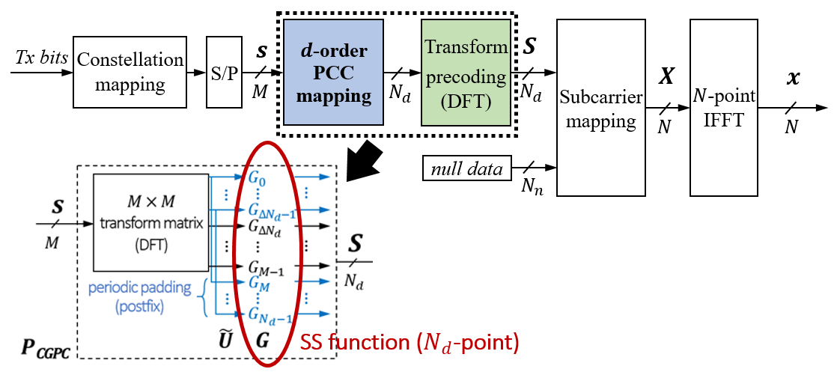
Figure 3.7 Illustration of reducing computational complexity of DFT by GPC.
The example impulse responses of $G_{k}^{d}$ with $N=\text{512}$, $N_{d}=\text{48}$, and$d=\text{1, 2, 3}$ are depicted in Fig. 3.8. As seen in Fig. 3.8a and b, $\left|G_{k}^{1}\right|$ is equivalent to the raised cosine (RC) spectrum-shaping vector [55] if $d=\text{1}$ is used for the proposed method and the roll-off factor is $β=\text{1}$ ($β=\text{0–1}$). This is because the half-sine curve in Eq. (3.17) is exactly consistent with the absolute value of the RC curve. For a higher-order SS, as shown in Fig. 3.8c to f, shorter-period cosine curves described in Eq. (3.18) would be multiplied by the half-sine curve, making the signal spectrum more band-limited.
(a) | (b)
(c) | (d)
(e) | (f)
Figure 3.8 Example impulse responses $G_{k}^{d}$ with $N=\text{512}$ and $M=\text{48}$ for (a, b) $d=\text{1}$ (c, d) $d=\text{2}$, and (e, f) $d=\text{3}$.
      - Computational Complexity
In this subsection, we analyze the computational complexity increase of PCC-based DFT precoding compared with conventional DFT precoding. According to Eqs. (3.11) and (3.13), the PCC-based DFT precoded data vector $S={\left[S_{0}, …, S_{N_{d}-1}\right]}^{T}$ can be rewritten as:
$$S=P_{GPC}s=F_{N_{d}}Ps.$$ | (3.21)
The PCC demapping matrix is given by $P^{†}$. By mathematically evaluating the matrices $P$ and $P^{†}$, the PCC mapping and demapping increase $N_{d}$ complex multiplications for the transmitter and $N_{d}2^{-1}+N_{d}2^{-d}=N_{d}\left(2^{-1}+2^{-d}\right)$ complex multiplications and $N_{d}2^{-d}$ complex additions for the receiver. However, as each PSK/QAM symbol only needs one complex multiplication to generate the results of $d$-order PCC-mapped symbols, the increased number of complex multiplications for the transmitter can be further reduced to $M={N_{d}}/{2^{d}}$. Therefore, the comparison of computational complexity between conventional DFT precoder/deprecoder and PCC-based one can be summarized as Table 3.2. As seen, PCC-based DFT precoding requires $O\left(M^{2}\right)$ operations whose complexity is consistent with conventional DFT precoding, where $O\left(∙\right)$ is the Big-O notation. That is, the computational complexity increase of DFT precoding is almost negligible when PCC is applied. This makes PCC-DFT-s-OFDM more compatible with existing LTE/NR systems.
Table 3.2 Comparison of computational complexity between the conventional DFT precoding and PCC-based DFT precoding.
Computational complexity |  | Conventional DFT precoding ($d=0$) |  |  |  | PCC-based DFT  precoding ($d>0$)
 |  | Function |  | Big-O |  | Function |  | Big-O
Number of complex multiplications | Tx | $${N_{d}}^{2}$$ |  | $$O\left({N_{d}}^{2}\right)$$ |  | $$N_{d}2^{-d}+{N_{d}}^{2}$$ |  | $$O\left({N_{d}}^{2}\right)$$
Number of complex multiplications | Rx | $${N_{d}}^{2}$$ |  | $$O\left({N_{d}}^{2}\right)$$ |  | $${N_{d}2^{-d}+N_{d}}^{2}$$ |  | $$O\left({N_{d}}^{2}\right)$$
Number of complex additions | Tx | $$N_{d}\left(N_{d}-1\right)$$ |  | $$O\left({N_{d}}^{2}\right)$$ |  | $$N_{d}\left(N_{d}-1\right)$$ |  | $$O\left({N_{d}}^{2}\right)$$
Number of complex additions | Rx | $$N_{d}\left(N_{d}-1\right)$$ |  | $$O\left({N_{d}}^{2}\right)$$ |  | $$N_{d}\left(2^{-1}+2^{-d}\right)$$  $$+N_{d}\left(N_{d}-1\right)$$ |  | $$O\left({N_{d}}^{2}\right)$$
    - Numerical Results
In this subsection, the performance of PCC-DFT-s-OFDM discrete baseband signals is evaluated in terms of PAPR, BER, and PSD, where the latter two also consider the scenarios of a single user (medium bandwidth only) and two users (medium bandwidth and narrow bandwidth). The system parameterization conforming to the 3GPP LTE/NR baseband standards [50], [51] are listed in Table 3.3.
Table 3.3 System parameterization for PCC-DFT-s-OFDM.
Parameter | Value
Carrier bandwidth | 10 MHz
Subcarrier spacing | 15 kHz
FFT size ($N$) | 1024
Number of allocated subcarriers for User 1 (medium bandwidth) | 144 (12 PRBs)
Number of allocated subcarriers for User 2 (narrow bandwidth) | 48 (4 PRBs)
CP length | 72
Modulation | ${\text{π}}/{\text{2}}$-BPSK, QPSK, 16-QAM
      - CCDF of PAPR
Figure 3.9 shows the PAPR CCDFs of PCC-DFT-s-OFDM at $d=\text{0, 1, 2, 3}$ for PSK and QAM signals. The PAPR performance of both signals improves significantly by changing $d=\text{0}$ to $d=\text{1}$. In Fig. 3.9a, the PAPR performances of all regular PSK signals appear similar for each given $d$ and can be improved further as $d$ increases. The PAPR performance curve of ${\text{π}}/{\text{2}}$-BPSK at $d=\text{1}$ almost overlaps that of the regular PSKs at $d=\text{2}$. This indicates that the PAPR performance for ${\text{π}}/{\text{2}}$-BPSK is greatly superior to that of regular PSK.
However, Fig. 3.9b shows that the improvements in the PAPR of QAM signals when $d=\text{3}$ are lower than when $d=\text{2}$. This indicates that the PAPR performance is not always improved as $d$ increases. This result supports the inferences made in Section 3.2.3.1 that PCC-DFT-s-OFDM filters provide a minor reduction in PAPR performance for dynamic-envelope symbols because they are moving average-like.
(a)
(b)
Figure 3.9 CCDF comparison of PAPR at $d=\text{0, 1, 2, 3}$ for
(a) PSKs and (b) QAMs.
      - Power Spectral Density
Figure 3.10 shows the sub-band PSD performances of the PCC-DFT-s-OFDM at $d=\text{0, 1, 2, 3}$ for the ${\text{π}}/{\text{2}}$-BPSK, QPSK, and 16-QAM signals. The maximum power for each simulation was normalized to 0 dB to ensure a fair comparison. As $d$ increased, the proposed method concentrated the in-band spectrum and diminished the out-of-band energy. Furthermore, the latter effect would be obvious if PA was considered. Although the PAPR performances of these three kinds of modulations were quite different, their extent of spectrum spreading due to nonlinear distortion was similar. This means that even for low-order/PAPR modulations in DFT-s-OFDM (i.e., ${\text{π}}/{\text{2}}$-BPSK and QPSK), there is still only limited improvement for PSD when PA nonlinearity is concerned.
(a) | (b)
(c) | (d)
Figure 3.10 Single-user PSD performances of PCC-DFT-s-OFDM for different modulations at (a) $d=\text{0}$, (b) $d=\text{1}$, (c) $d=\text{2}$, and (d) $d=\text{3}$.
The advantage of lessening the out-of-band radiation can be underlined from the inter-user interference perspective. As seen in Fig. 3.11a, the side-lobes of two spectrum-adjacent users severely influence the main-lobe of each other when $d=0$. Figure 3.11b to d displays the mitigation of ICI for $d=\text{1, 2, 3}$; as $d$ increases, the main-beams of the two users increasingly separate and their PSDs overlap less, achieving lower interference plus noise ratio (SINR). Such SINR improvement is especially significant when more users are considered.
(a) | (b)
(c) | (d)
Figure 3.11 Two-user PSD performances of PCC-DFT-s-OFDM for 16-QAM signals at (a) $d=\text{0}$, (b) $d=\text{1}$, (c) $d=\text{2}$, and (d) $d=\text{3}$.
      - Bit Error Rate
Figure 3.12 shows uncoded BER performance comparisons of PCC-DFT-s-OFDM over the AWGN channel at $d=\text{0, 1, 2, 3}$ for single-user ${\text{π}}/{\text{2}}$-BPSK, QPSK, and 16-QAM signals. When ${\text{π}}/{\text{2}}$-BPSK at $d=\text{0}$, the BER curve is almost identical to the lower bound, implying that ${\text{π}}/{\text{2}}$-BPSK has a high tolerance for PA nonlinearity. For QPSK, there is a slight degradation in BER at $d=\text{0}$. However, its performance can be improved to match the lower bound at $d=\text{1}$. For 16-QAM, the BER improvement is remarkable at $d=\text{1, 2}$ but moderate at $d=\text{3}$ owing to the inferior PAPR performance.
Figure 3.12 Single-user BER performances of PCC-DFT-s-OFDM over AWGN channel for different values of $d$.
Figure 3.13 shows the BER results over AWGN and Rayleigh fading channel. The performance of 16-QAM signals improves significantly at $d=\text{1}$ while appearing close to the undistorted signals at $d=\text{2, 3}$. The results for ${\text{π}}/{\text{2}}$-BPSK and QPSK are almost the same as those for the undistorted signals at each value of $d$. Despite this, it is interesting that the proposed method essentially enhances the immunity of DFT-s-OFDM to frequency-selective fading thanks to a property akin to the SS technique. As shown in Fig. 3.8, the band of the PCC-DFT-s-OFDM signals becomes narrower through the higher order of PCC symbols, mitigating the interference from the frequency-selective fading channel.
Figure 3.13 Single-user BER performances of PCC-DFT-s-OFDM over Rayleigh fading channel for different values of $d$.
Figure 3.14 presents the BER performances of two spectrum-adjacent users whose PSD refer to Fig. 3.11. Clearly, serious BER degradation was found when inter-user interference is further considered. By applying PCC to DFT-s-OFDM, the BER of both users is greatly improved because their side-lobes have been suppressed to avoid interfering with the main-beam of each other. However, since more allocated
(a) | (b)
(c) | (d)
Figure 3.14 Two-user BER performances of PCC-DFT-s-OFDM over Rayleigh channel for different values of $d$ for (a) User 1 (with medium bandwidth) for ${\text{π}}/{\text{2}}$-BPSK and QPSK, (b) User 2 (with narrow bandwidth) for ${\text{π}}/{\text{2}}$-BPSK and QPSK, (c) User 1 for 16-QAM, and (d) User 2 for 16-QAM.
bandwidth causes a greater side-lobe component than that of other users, the BER of User 1 mainly improves at $d=\text{1}$ (see Fig. 3.14a and c) while that of User 2 mainly improves at $d=\text{2}$ (see Fig. 3.14b and d).
      - Discussion
The simulation results show that the BER enhancement is evident even for low-order modulations (i.e., ${\text{π}}/{\text{2}}$-BPSK and QPSK) if both PA nonlinearity and inter-user interference are considered. Furthermore, the proposed method can effectively improve PSD performance and the immunity of the frequency-selective fading channel for all modulations in DFT-s-OFDM systems that benefit from the transformed-domain data localization of PCC symbols. The extent of the improvement for PAPR, PSD and BER performances depends on the value of $d$, which would decrease data rate $2^{d}$ times. Indeed, this might be the main drawback of the proposed method. However, aiming to improve the flexibility of the trade-off between spectral efficiency and the other performances for DFT-s-OFDM, the proposed architecture creates the opportunity for further improvement in terms of PAPR, PSD and BER performances when the channel condition allows bandwidth-greedy transmission. Otherwise, one can reduce to the conventional DFT-s-OFDM for the transmission by using $d=\text{0}$.
    - Bit-Level Implementation for PCC Mapping
Although PCC-DFT-s-OFDM improves the flexibility of DFT-s-OFDM on the trade-off between peak-to-average power ratio performance and spectral efficiency, deploying it on numerous UEs as enhanced uplink signalling becomes a practical issue. In this subsection, a bit-level implementation of PCC mapping is presented, so that the compatibility of implementation of corresponding circuits on UE transmitters would make the deployment more easily. By taking LTE/NR standards as examples, the equivalency of bit/symbol-level implementations is validated in terms of bit error rate performance.
      - Concept Description
Since the PCC mapping is essentially a data duplication procedure, the resulting “dummy symbols” also represent the “dummy bits” that can be generated and padded into the input bit sequence. Let $z^{r}≜\left[b_{0}^{r} b_{1}^{r}… b_{\log_{2}{M}-1}^{r}\right]$ is the bit stream carried by the $r$-th symbol of $s$, where $b_{i}^{r}∈\left\{0\text{, 1}\right\}$, $i=0\text{, …,} \log_{2}{M}-1$, and $M$ is the alphabet size of the PSK/QAM constellation. First, we define the $d$-order PCC mapped symbol vector as
$s_{pcc}=Ps={\left[\underset{2^{d}∙M=N_{d}}{\underbrace{\overset{2^{d}}{\overbrace{s_{0}\text{, …, }-s_{0}}}\text{, }\overset{2^{d}}{\overbrace{s_{1}\text{, …,} -s_{1}}}\text{, …,} \overset{2^{d}}{\overbrace{s_{M-1}\text{, …, }-s_{M-1}}}}}\right]}^{T}$, | (3.22)
thereby the corresponding PCC-mapped bit sequence can be expressed as
$z_{pcc}=\left[\underset{2^{d}∙M=N_{d}}{\underbrace{\overset{2^{d}}{\overbrace{z^{0}…{\overline{z}}^{0}}}\overset{2^{d}}{\overbrace{z^{1}…{\overline{z}}^{1}}}…\overset{2^{d}}{\overbrace{z^{M-1}…{\overline{z}}^{M-1}}}}}\right]$, | (3.23)
where ${\overline{z}}^{r}$ is defined as the bit stream corresponding to $-s_{r}$, $r=0\text{, …, }M-1$. Consequently, the PCC-mapped symbols vector $s_{pcc}$ can be also generated by PSK/QAM mapping by Eq. (3.23).
Next, the scheme of obtaining ${\overline{z}}^{r}$ from $z^{r}$ is developed. Based on the symmetry property, a scheme to convert $z^{r}$ to ${\overline{z}}^{r}$ is proposed. Since Gray code is commonly used in modern communication systems, albeit many versions according to distinct specifications, the implementation of the bit-level PCC mapping for PCC-DFT-s-OFDM becomes more feasible. In the following subsections, the proposed scheme is presented through examples based on 3GPP LTE/NR standards.
      - Regular Modulations
According to the bit-labelling equation described in [50], [51], the quadrant in which each symbol is located on the in-phase-quadrature (IQ)-plane for the regular modulations, i.e., BPSK, QPSK, and 16/64/256-QAM, depends on its first two mapping bits. For example, the 16-QAM bit-labelling equation for each alphabet is given by
$$α_{χ}=\frac{\text{1}}{\sqrt{\text{10}}}\left\{\left(\text{1}-\text{2}b_{0}\right)\left[\text{2}-\left(\text{1}-\text{2}b_{2}\right)\right]+\text{j}\left(\text{1}-\text{2}b_{1}\right)\left[\text{2}-\left(\text{1}-\text{2}b_{3}\right)\right]\right\}\text{,}$$ | (3.24)
where $χ∈\left\{\text{0, …, 15}\right\}$ is the labelled number of the alphabet obtained by the decimal conversion of $b_{0}b_{1}b_{2}b_{3}$. The constellation diagram with the corresponding bit stream based on Eq. (3.24) is also demonstrated in Fig. 3.14. It shows clearly that the value of $b_{0}$ and $b_{1}$ determine the signs of the I- and Q-term of the symbol, respectively. Therefore, the corresponding bit steam of the inversed symbol pair for regular modulations can be yielded by taking a logical NOT operation (denoted as ${\overline{b}}_{i}$) for the first two bits of the symbol (see Table 3.4). An example of PCC-mapped symbol pair for 16-QAM is illustrated in Fig. 3.15.
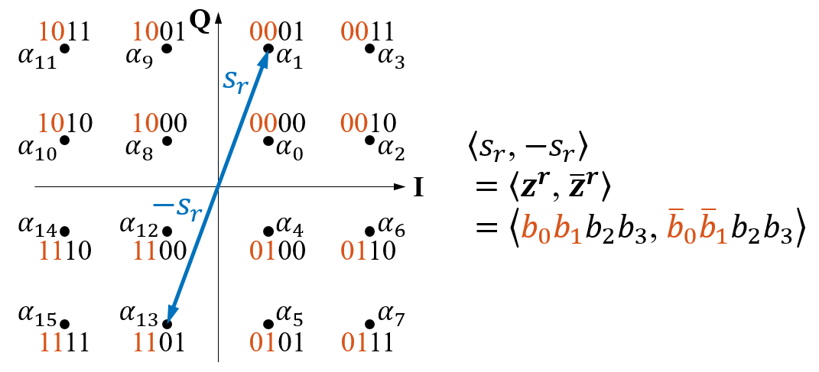
Figure 3.15 Example of PCC-mapped symbol pair for 16-QAM constellation.
Table 3.4 Bit stream conversion for 3GPP LTE/NR modulations.
Modulation | $$M$$ | Conversion of $z^{r}$ to ${\overline{z}}^{r}$
BPSK | 2 | $${\overline{b}}_{0}$$
QPSK | 4 | ${\overline{b}}_{0}{\overline{b}}_{1}$
16-QAM | 16 | ${\overline{b}}_{0}{\overline{b}}_{1}b_{2}b_{3}$
64-QAM | 64 | ${\overline{b}}_{0}{\overline{b}}_{1}b_{2}b_{3}b_{4}b_{5}$
256-QAM | 256 | ${\overline{b}}_{0}{\overline{b}}_{1}b_{2}b_{3}b_{4}b_{5}b_{6}b_{7}$
      - π/2-BPSK
However, the proposed scheme for regular modulations cannot be applied directly to the rotated modulations because the alphabet set of the latter is a superset of the regular modulations. This means that the procedure for ${\text{π}}/{\text{2}}$-BPSK needs to be redesigned. Fortunately, as the alphabet set of ${\text{π}}/{\text{2}}$-BPSK (see Fig. 3.16a) is consistent with that of QPSK (see Fig. 3.16b), we can generate the PCC-mapped ${\text{π}}/{\text{2}}$-BPSK symbols using a QPSK modulator. By pre-mapping the ${\text{π}}/{\text{2}}$-BPSK bit to QPSK bit stream (see Table 3.5), we can perform bit-level PCC mapping for QPSK to determine equivalent PCC-mapped ${\text{π}}/{\text{2}}$-BPSK symbols.
(a) (b)
Figure 3.16 Comparison of constellation and alphabet set.
Table 3.5 ${\text{π}}/{\text{2}}$-BPSK-to-QPSK bit pre-mapping.
Symbol Index ($r$) | Source bit | QPSK  mapping bits | Alphabet
Even | 0 | 00 | $$α_{0}$$
Even | 1 | 11 | $$α_{3}$$
Odd | 0 | 10 | $$α_{2}$$
Odd | 1 | 01 | $$α_{1}$$
To demonstrate the equivalency of the alphabet sets, the bit sequence $\left[z^{0}z^{1}z^{2}z^{3}\right]=\left[0010\right]$ transmitted over four ${\text{π}}/{\text{2}}$-BPSK symbols with $d=\text{1}$ is given as follows. For the generation of PCC-mapped symbols in the symbol level, the given bit sequence is first mapped to the IQ-plane:
$$\left[0010\right]⟼\left[α_{0}\text{, }α_{2}\text{, }α_{3}\text{, }α_{2}\right]\text{,}$$ | (3.25)
where $• ⟼ •$ is the bit-mapping operation. Let $s=\left[s_{0}\text{, …, }s_{3}\right]=\left[α_{0}\text{, }α_{2}\text{, }α_{3}\text{, }α_{2}\right]$ be the input for Eq. (3.22), we have the PCC-mapped symbol vector
$$s_{pcc}=\left[s_{0}\text{, …, }s_{7}\right]=\left[α_{0}\text{, }α_{3}\text{, }α_{2}\text{, }α_{1}\text{, }α_{3}\text{, }α_{0}\text{, }α_{2}\text{, }α_{1}\right].$$ | (3.26)
To generate PCC-mapped symbols in the bit level, the given bit sequence $\left[0010\right]$ is first converted to the QPSK bits by Table 3.5 as $\left[z^{0}z^{1}z^{2}z^{3}\right]=\left[00 10 11 10\right]$. The following PCC-mapped bit sequence can then be obtained by Eq. (3.23):
$$\left[z^{0}{\overline{z}}^{0}z^{1}{\overline{z}}^{1}z^{2}{\overline{z}}^{2}z^{3}{\overline{z}}^{3}\right]=\left[00 11 10 01 11 00 10 01\right]\text{,}$$ | (3.27)
where ${\overline{z}}^{r}≜{\overline{b}}_{0}{\overline{b}}_{1}$ is defined as the bit stream conversion of QPSK as described in Table 3.4. After QPSK modulation, the corresponding symbols in Eq. (3.27) are gained by
$$\left[00 11 10 01 11 00 10 01\right]⟼\left[α_{0}\text{, }α_{3}\text{, }α_{2}\text{, }α_{1}\text{, }α_{3}\text{, }α_{0}\text{, }α_{2}\text{, }α_{1}\right]\text{.}$$ | (3.28)
Here, the result of Eq. (3.26) is the same as that of Eq. (3.28), showing that the bit-level PCC mapping for ${\text{π}}/{\text{2}}$-BPSK can be achieved by a QPSK modulator only with an additional ${\text{π}}/{\text{2}}$-BPSK-to-QPSK bit pre-mapping. Note that the PCC-DFT-s-OFDM receiver still utilizes original ${\text{π}}/{\text{2}}$-BPSK demodulator after PCC demapping.
      - BER Equivalency Validation
The equivalency of DFT-s-OFDM applying bit/symbol-level implemented PCC mappings ($d=\text{0–3}$) are validated by the numerical simulation of BER performance for ${\text{π}}/{\text{2}}$-BPSK and regular modulation (taking 16-QAM for example) over Rayleigh fading channel. The parameterization is set to $N_{d}=\text{144}$, $N=\text{1024}$ and $L=\text{72}$, where $L$ equals to the CP length. The solid state PA model [18] with smoothness factor $p=\text{2}$ and 3dB IBO is invoked for PA nonlinearity. At the receiver, perfect synchronization and channel estimation are assumed and symbol-level PCC demapping is adopted. By using the same dataset of random input bits, Fig. 3.17 shows the identical BER performances of bit/symbol-level PCC mapping for PCC-DFT-s-OFDM transmitters for ${\text{π}}/{\text{2}}$-BPSK and 16-QAM at different $d$. Bearing in mind that any kind of Gray code bit labelling for regular modulations can achieve such equivalency by simply modifying the conversion rules listed in Table 3.4.
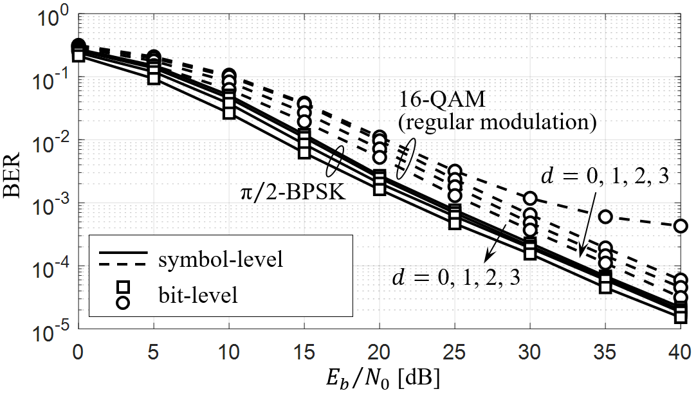
Figure 3.17 BER performance comparison of bit/symbol-level implementation for PCC-DFT-s-OFDM for ${\text{π}}/{\text{2}}$-BPSK and 16-QAM.
  - Summary
In this chapter, we present an improved structure of GPC and introduce a novel PCC-based waveform of DFT-s-OFDM with adjustable PAPR. The spectral analysis of PCC-DFT-s-OFDM indicates that PCC-DFT-s-OFDM can be regarded as a DFT-based GPC variant whose length of SS function is controlled by the applied order of PCC mapping. Both adjustable PAPR reduction techniques turn DFT-s-OFDM to achieve a wide-range trade-off between the performance of PAPR and spectral efficiency. As DFT-s-OFDM is standardized as LTE/NR uplink waveform, enhancing the flexibility of such trade-off significantly benefits the adaptability of multi-RAT transmissions.
On the other hand, the implementation of PCC-DFT-s-OFDM on numerous UEs might be unfeasible due to the incompatibility of the corresponding circuit. A bit-level PCC mapping scheme is proposed for making the deployment easier. Its equivalency is developed on the symmetricity of Gray code bit labelling and is shown to be a promising alternative implementation for PCC-DFT-s-OFDM transmitters.

NONLINEARITY MITIGATION AT RECEIVERS
  - Iterative Subcarrier Regularization (ISR)
In this section, the proposed EPGA is firstly presented, followed by the two crucial parts of the proposed ISR scheme, including the prior knowledge on time (data) and frequency (transformed) domain, are described. Then we present the analysis of the proposed ISR scheme.
    - Extended Papoulis-Gerchberg Algorithm (EPGA)
Papoulis-Gerchberg algorithm (PGA) has been taken as a powerful scheme for restoration of bandlimited signals. We introduce a generalization of the PGA, called Extended PGA (EPGA), so that a general signal can be handled.
A discrete signal with $N$ samples can be described by an $N$-dimensional complex vector $v={\left[v_{0}, …, v_{N-1}\right]}^{T}$, $v_{n}∈C^{N}$, and its known sample vector is defined as
$$K_{D}=I_{D}v\text{,}$$ | (4.1)
where $I_{D}$ is an $N$-by-$N$ matrix with binary coefficients on its diagonal: ${\left[I_{D}\right]}_{\left(j,j\right)} =\text{ 1}$ if the $j$-th sample in data domain is known and ${\left[I_{D}\right]}_{\left(j,j\right)} = \text{0}$ otherwise. We denote the number of the known samples as $N_{D}∈\left\{\text{0}, …, N\right\}$, thus the lost-knowledge ratio of data domain is $L_{D}=\text{1}-{N_{D}}/N$.
In the transformed domain, the DFT of the signal $v$ is the vector $V∈C^{N}$ given by $V=F_{N}v$. Its prior knowledge vector can be written as
$$K_{T}=I_{T}V\text{,}$$ | (4.2)
where $I_{T}$ is an $N$-by-$N$ matrix with binary coefficients on its diagonal: ${\left[I_{T}\right]}_{\left(j,j\right)} =\text{ 1}$ if the $j$-th sample in transformed domain is known and ${\left[I_{T}\right]}_{\left(j,j\right)} =\text{ 0}$ otherwise. Also, we denote the number of the known samples as $N_{T}∈\left\{\text{0}, …,N\right\}$, and the knowledge ratio of transformed domain is $K_{T}={N_{T}}/N$. According to [84], the errorless signal reconstruction can be achieved if $L_{D}≤K_{T}$ is satisfied. The algorithm starts with ${\hat{v}}^{\left(i=0\right)}=K_{D}$, where iteration number $i$ is set to zero as an initial guess. Then, the iterative process consists of following three steps:
- Apply the transformed-domain partial knowledge $K_{T}$ to ${\hat{v}}^{\left(i\right)}$ :
$${\hat{v}}^{\left(i+1\right)}=F_{N}^{H}\left[\left(I_{N}-I_{T}\right)F_{N}{\hat{v}}^{\left(i\right)}+K_{T}\right].$$ | (4.3)
- Replace known samples in the estimated ${\hat{v}}^{\left(i+1\right)}$:
$${\hat{v}}^{\left(i+1\right)}=\left(I_{N}-I_{D}\right){\hat{v}}^{\left(i+1\right)}+K_{D}.$$ | (4.4)
- Verify if the process converged to the specified threshold $δ$ based on the normalized mean square error (NMSE), i.e.,
$$NMSE\left({\hat{v}}^{\left(i\right)}\right)=\frac{{\left\|{\hat{v}}^{\left(i\right)}-{\hat{v}}^{\left(i+1\right)}\right\|}_{2}^{2}}{{\left\|{\hat{v}}^{\left(i\right)}\right\|}_{2}^{2}}<δ.$$ | (4.5)
If not, return to the first step with $i=i+1$.
    - Frequency-Domain Prior Knowledge
The knowledge of the transformed domain, viz., frequency domain, is referred to as the subcarrier mapping described in 802.11ah standard [29], which consists of data, pilot, and null subcarriers (i.e., guard and DC subcarriers), with options of carrier bandwidth (CBW) including 1, 2, 4, 8, and 16 MHz. In this study, we use CBW1 (1 MHz) parameterization to demonstrate the proposed algorithm, where its subcarrier mapping is illustrated in Fig. 4.1.
Figure 4.1 Frequency-domain prior knowledge from the subcarrier mapping based on the 802.11ah standard (CBW1 parameterization).
Table 4.1 802.11ah (CBW1)-based frequency-domain prior knowledge.
Vector index | Carrier index | Value | Carrier type | Vector index | Carrier index | Value | Carrier type
0 | 0 | 0 | DC | 16 | -16 | 0 | guard
1 | 1 | $M$kinds | data | 17 | -15 | 0 | guard
⁝ | ⁝ | ⁝ | ⁝ | 18 | -14 | 0 | guard
6 | 6 | $M$kinds | data | 19 | -13 | $M$kinds | data
7 | 7 | 1 | pilot | ⁝ | ⁝ | ⁝ | ⁝
8 | 8 | $M$kinds | data | 24 | -8 | $M$kinds | data
⁝ | ⁝ | ⁝ | ⁝ | 25 | -7 | -1 | pilot
13 | 13 | $M$kinds | data | 26 | -6 | $M$kinds | data
14 | 14 | 0 | guard | ⁝ | ⁝ | ⁝ | ⁝
15 | 15 | 0 | guard | 31 | -1 | $M$kinds | data
*Deterministic and probabilistic prior information is denoted in red and blue, respectively.
A very unique design of the proposed ISR is that it only takes the protocol operation parameters of 802.11ah, including the values of pilot and null subcarriers, as the frequency-domain prior knowledge (denote as solid dots in Fig. 4.1) and inputs of the rule-based EPGA. Accordingly, the first step of ISR can be described by rewriting Eq. (4.3) as
$${\hat{q}}^{\left(i+1\right)}=F_{N}^{H}\left[\left(I_{N}-I_{T}^{ISR}\right){\hat{Q}}^{\left(i\right)}+K_{T}^{ISR}\right]\text{,}$$ | (4.6a)
where ${\hat{q}}^{\left(i\right)}=F_{N}^{H}{\hat{Q}}^{\left(i\right)}$, $K_{T}^{ISR}$ is the prior knowledge vector according to the standard (the example vector for CBW1 parameterization is given in Table 4.1), and $I_{T}^{ISR}$ is an $N$-by-$N$ matrix with binary coefficients on its diagonal: ${\left[I_{T}^{ISR}\right]}_{\left(j,j\right)} = 1$ if the $j$-th frequency component is a pilot or null subcarrier and ${\left[I_{T}^{ISR}\right]}_{\left(j,j\right)} = 0$ otherwise. In this case, the ratio of the prior knowledge is $K_{T}^{ISR}={\left(N_{p}+N_{n}\right)}/N={\left(\text{6}+\text{2}\right)}/{\text{32}} = \text{25\%}$, which implies a successful reconstruction of an incomplete signal vector cannot exceed 25% lost samples according to [84].
On the other hand, though the received data subcarriers herein are taken as unknown part and do not contribute to the reconstruction process in each iteration (denote as hollow dots in Fig. 4.1), they actually carry the probabilistic prior knowledge of $M$-ary constellation mapping that may help the subsequent SC. Such a concept was firstly report in DAR [85] where all PSK/QAM symbols were performed hard decision iteratively for SC. To combine the DAR process, the action of applying frequency-domain prior knowledge can be re-expressed as the so-called ISR:
$${\hat{q}}^{\left(i+1\right)}=F_{N}^{H}\left[\left(I_{N}-I_{T}^{ISR}\right)Q_{HD}^{\left(i\right)}+K_{T}^{ISR}\right]\text{,}$$ | (4.6b)
where
$${\hat{Q}}_{HD}^{\left(i\right)}=\underset{X∈M\text{-QAM}}{arg min}\left({\left\|{\hat{Q}}^{\left(i\right)}-X\right\|}_{2}\right)\text{,} {\hat{Q}}^{\left(i\right)}∈\text{data subcarriers.}$$ | (4.6c)
For the convenience, we call Eq. (4.6a) as ISR scheme Ⅰ (ISR-Ⅰ) and Eq. (4.6b) as ISR scheme Ⅱ (ISR-Ⅱ) in the rest of the dissertation. Their performance comparison and discussion will be provided in Section 4.1.5.
    - Time-Domain Prior Knowledge
Since nonlinear noise on a time-domain OFDM symbol is mainly caused by large-amplitude samples due to the severe saturation, it is reasonable to retain the low-amplitude samples in each iteration as time-domain prior knowledge. As illustrated in Fig. 4.2, the severely-saturated samples are taken as the lost ones that needs reconstruction by calculating the estimated saturation level:
$${\hat{A}}_{sat}=q_{RMS}∙{10}^{{IBO}/{20}}\text{,}$$ | (4.7)
where $IBO$ is the value of IBO in dB used in the transmission known in advance by the receiver, and $q_{RMS}=\sqrt{{\sum_{n=0}^{N-1}{{\left|q_{n}\right|}^{2}}}/N}$, $q_{n}∈q$, $q=F_{N}^{H}Q$. The known sample determination can be achieved by creating the denotation matrix:
$${\left[I_{D}^{ISR}\right]}_{\left(j,j\right)}=\left\{\begin{aligned}1\text{,} q_{n}<{\hat{A}}_{sat} \\ 0\text{,} q_{n}≥{\hat{A}}_{sat}\end{aligned}\right.\text{, }0≤j\text{, }n≤N-1\text{.}$$ | (4.8)
As a result of Eq. (4.1) and Eq. (4.8), the time-domain prior knowledge of the proposed ISR scheme can be obtained by
$$K_{D}^{ISR}=I_{D}^{ISR}q.$$ | (4.9)
Figure 4.2 Lost samples determination and initial guess settings for the saturated signal in time domain.
Since the saturated signals are highly correlated with their original samples, they can be taken as the best initial guesses (instead of using zero samples as in the bare PGA) in the restoration process. Note that inserting zero samples is a highly nonlinear process that reduces the smoothness of a signal and introduces much in-band and out-of-band noises. Therefore, as shown in Fig. 4.2, the proposed algorithm starts with ${\hat{q}}^{\left(i=0\right)}=q$ (green hollow dots) instead of ${\hat{q}}^{\left(i=0\right)}=K_{D}^{ISR}$ (orange hollow dots). We will indicate in Section 4.1.4that using the equalized samples as the initial guess can significantly accelerate the convergence compared with the case of using zeros.
By Eq. (4.8), the time-domain lost-knowledge ratio can be expressed by $L_{D}^{ISR}=\text{1}-{N_{D}}/N$, where $N_{D}∈\left\{\text{0}, …, N\right\}$ is the number of ones in $I_{D}^{ISR}$. Since the proposed ISR works under the criterion $L_{D}^{ISR}≤K_{T}^{ISR}$ [84], the value of $L_{D}^{ISR}$, which is dominated by the IBO of the transmit PA according to Eq. (4.7), can be used to estimate the recovery limitation. To this end, we perform Monte Carlo simulations with $\text{5×}{\text{10}}^{\text{5}}$ random OFDM symbols to obtain the CCDF of 802.11ah received samples suffered from a different extent of nonlinearity. Figure 4.3a and b shows the CCDF of the amplitude for signal $q$ over the poor (${E_{b}}/{N_{0}}=\text{0}$ dB) and good (${E_{b}}/{N_{0}}=\text{20}$ dB) wireless channel, respectively, where ${E_{b}}/{N_{0}}$ is the normalized signal-to-noise ratio (SNR). It can be clearly found that decreasing the IBO would increase $L_{D}^{ISR}$ under any channel quality. Table 4.2 provides more results of $L_{D}^{ISR}$ with/without the channel noise (${E_{b}}/{N_{0}}=\text{0, 5, 10, 15, 20}$ dB) for $IBO=\text{0–8}$ dB. By matching the criterion $L_{D}^{ISR}≤\text{25\%}$, the smallest IBO is 2 dB according to the $L_{D}^{ISR}$ values marked with red color in Table 4.2. However, the analysis in [84] indicates that both the signal noise and iteration limit will degrade the performance of SC, making the maximum value of $L_{D}^{ISR}$ smaller than 25%, i.e., $K_{T}^{ISR}$. Therefore, effective SC may occur when the IBO is not lower than 3 dB. (Refer to the $L_{D}^{ISR}$ values marked with blue color in Table 4.2.)
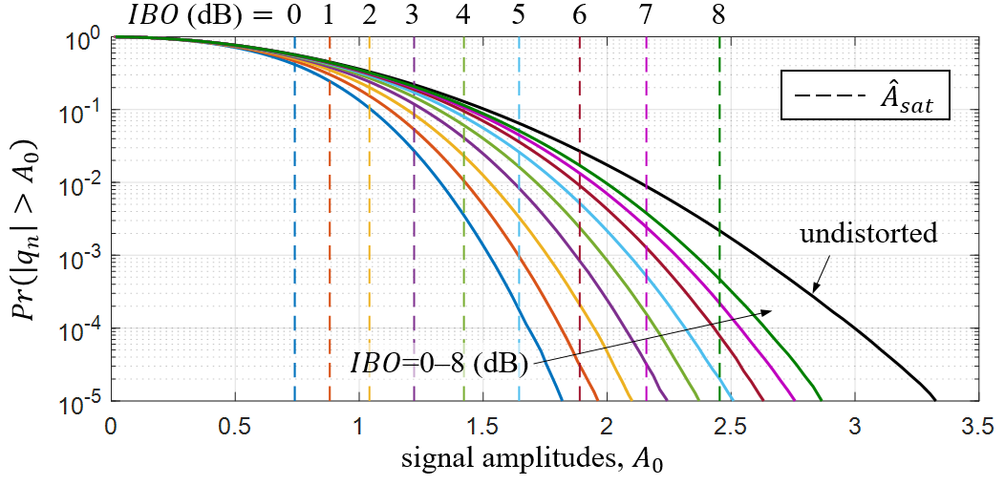
(a)
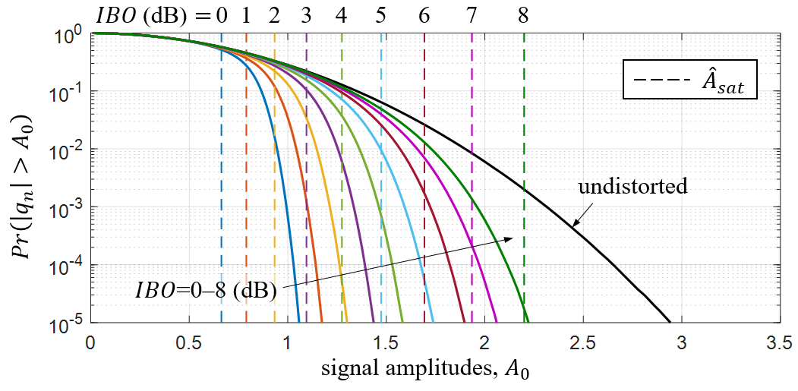
(b)
Figure 4.3 CCDF of $\left|q_{n}\right|$ for estimating $L_{D}^{ISR}$ over AWGN channel with
(a) ${E_{b}}/{N_{0}}=\text{0}$ dB (b)${E_{b}}/{N_{0}}=\text{20}$ dB.
Table 4.2 Time-domain lost-knowledge ratio (%) versus IBO and normalized SNR.
IBO  [dB] | ${E_{b}}/{N_{0}}$ [dB] |  |  |  |  | Undistorted
IBO  [dB] | 0 | 5 | 10 | 15 | 20 | Undistorted
0 | 43.1105 | 47.6518 | 50.9835 | 52.2034 | 52.5642 | 52.7401
1 | 31.5195 | 33.8598 | 36.1367 | 37.2726 | 37.6483 | 37.8244
2 | 20.8746 | 21.1574 | 21.8982 | 22.4990 | 22.7477 | 22.8544
3 | 12.2264 | 11.2761 | 10.8340 | 10.7607 | 10.7704 | 10.7842
4 | 6.1393 | 4.9494 | 4.1839 | 3.8467 | 3.7300 | 3.6785
5 | 2.5423 | 1.7208 | 1.2183 | 0.9935 | 0.9112 | 0.8734
6 | 0.8287 | 0.4532 | 0.2620 | 0.1863 | 0.1609 | 0.1480
7 | 0.1987 | 0.0849 | 0.0394 | 0.0255 | 0.0208 | 0.0188
8 | 0.0326 | 0.0104 | 0.0041 | 0.0023 | 0.0020 | 0.0018
    - Performance Evaluation
Based on the elaboration of frequency-domain and time-domain prior knowledge, we summarize the whole process of the proposed ISR in Algorithm 4.1 and evaluate its performance with 802.11ah CBW1 parameterization as follows. As ISR is an iterative nonlinear process whose two random variables, convergent iteration times (denoted as $i_{c}$) and convergent NMSE between restored and original signal (denoted as ${NMSE}_{i_{c}}={{\left\|x-{\hat{v}}^{\left(i_{c}\right)}\right\|}_{2}^{2}}/{{\left\|x\right\|}_{2}^{2}}$), are hard to be analytically featured, we empirically evaluate their performance in terms of two-dimensional joint probability density function (PDF), denoted as $f_{i_{c}\text{,} {NMSE}_{i_{c}}}\left(a\text{,} b\right)$, versus different IBO values. Here, the converge threshold $δ$ is set to ${\text{10}}^{\text{-6}}$ and $\text{5×}{\text{10}}^{\text{5}}$ random OFDM symbols are tested.
Algorithm 4.1 Iterative Subcarrier Regularization (ISR)
Input: $q$, $IBO$,$δ$
1: ${\hat{A}}_{sat}=q_{RMS}∙{10}^{{IBO}/{20}} \text{(4.7)}$
2: ${\left[I_{D}^{ISR}\right]}_{\left(j,j\right)}=\left\{\begin{aligned}1\text{,} q_{n}<{\hat{A}}_{sat} \\ 0\text{,} q_{n}≥{\hat{A}}_{sat}\end{aligned}\right.\text{, }0≤j\text{,} n≤N-1\text{ (4.8)}$
3: $K_{D}^{ISR}=I_{D}^{ISR}q \text{(4.9)}$
4: ${\hat{q}}^{\left(i=0\right)}=q$ // Initial guess
5: while $NMSE\left({\hat{q}}^{\left(i\right)}\right)<δ$ do
6: // Applying frequency-domain prior knowledge
7: if ISR-I is used then
8: ${\hat{q}}^{\left(i+1\right)}=F_{N}^{H}\left[\left(I-I_{T}^{ISR}\right){\hat{Q}}^{\left(i\right)}+K_{T}^{ISR}\right] \text{(4.6a)}$
9: end if
10: if ISR-II is used then
11: ${\hat{q}}^{\left(i+1\right)}=F_{N}^{H}\left[\left(I-I_{T}^{ISR}\right)Q_{HD}^{\left(i\right)}+K_{T}^{ISR}\right] \text{(4.6b)}$
12: end if
13: // Applying time-domain prior knowledge
14: ${\hat{q}}^{\left(i+1\right)}=\left(I-I_{D}^{ISR}\right){\hat{q}}^{\left(i+1\right)}+K_{D}^{ISR}$
15: end while
Output: ${\hat{q}}^{\left(i\right)}$

Figure 4.4 Joint PDF of convergent number of iteration and its NMSE ($f_{i_{c}\text{,} {NMSE}_{i_{c}}}\left(a\text{,} b\right)$) in $IBO=\text{1–5}$ dB for ISR-Ⅰ and ISR-Ⅱ schemes with different initial guesses.
Figure 4.4 shows the PDF of $f_{i_{c}\text{,} {NMSE}_{i_{c}}}\left(a\text{,} b\right)$ in $IBO=\text{1–5}$ dB for ISR-Ⅰ and ISR-Ⅱ schemes with different initial guesses (zeros/received samples). Clearly, the largest variances of $i_{c}$ and ${NMSE}_{i_{c}}$ appear at $IBO=\text{2}$ dB for all the considered schemes because the corresponding ratio of time-domain knowledge ($K_{T}^{ISR}$) is near to $L_{D}^{ISR}$ (see Table 4.2). In the view of convergence, it can be found that setting initial guesses as received samples is faster than setting as zeros (50–200 iterations reduce to 50–100 iterations), and ISR-Ⅱ scheme is faster than ISR-Ⅰ (50–100 iterations reduce to 1–10 iterations). The presence of AWGN nearly does not influence the convergence of ISR-Ⅱ scheme. For the convergent NMSE, the lowest NMSE of $IBO=\text{1}$ dB is worse than that of $IBO=\text{2–5}$ dB since the former does not satisfy the criterion $L_{D}^{ISR}≤K_{T}^{ISR}$[84]. Therefore, the distributions of convergent NMSE between $IBO=\text{2–5}$ dB are almost identical because the presence of the noise is the only factor to control the performance of convergent NMSE when $L_{D}^{ISR}≤K_{T}^{ISR}$ (i.e., all time-domain lost-knowledge ratios are smaller than 25% for $IBO=\text{2–5}$ dB as presented in Table 4.1). Based on these findings, the simulations in the subsequent section will be focused on $IBO=\text{2–5}$ dB.
    - Computational Complexity
The computational complexity of the proposed schemes, ISR-Ⅰ and ISR-Ⅱ, are expressed in the big-O notation which is related to the number of subcarriers of OFDM symbols [86]. From Algorithm 4.1, the ISR scheme in each iteration is subject to complexity $O\left(2N\log_{2}{N}\right)$ to perform the FFT/IFFT pair and $O\left(2N\right)$ to update the prior knowledge in both domains. As ISR-Ⅱ in Eq. (4.6b) needs to perform hard decision for $N_{d}$ data subcarriers to obtain $Q_{HD}^{\left(i\right)}$ with extra complexity $O\left(N_{d}M\right)$, the computational complexity with $i_{t}$ iterations for ISR-Ⅰ and ISR-Ⅱ can be summarized as $O\left(2N\left(\log_{2}{N}+1\right)i_{t}\right)$ and $O\left(2N\left(\log_{2}{N}+1\right)i_{t}+N_{d}Mi_{t}\right)$, respectively. Note that the value of $N_{d}$ refers to the parameterization of 802.11ah protocol.
Consequently, the resulting complexity shows that the additional complexity of the receiver for AP with ISR only comes from the reuse of functions of FFT and hard decision and is mainly dominated by the number of iterations. The proposed scheme can be seamlessly incorporated into 802.11ah chips as longer processing time is tolerant in IoT networking.
  - Simulation Results
Simulation is conducted to verify the proposed SC scheme regarding a number of performance metrics, including PSD, BER, and total degradation (TD). Based on these results, an estimation on the PA efficiency improvement is provided. The same 802.11ah-CBW1 parametrization [29] used in section 4.1.5 is adopted in the simulation, i.e., $N=\text{32}$ subcarriers including 2 pilot subcarriers, 6 null subcarriers, and 24 data subcarriers (using 16-QAM). The CP length is $P=L=N/{\text{4}}$ [29].
    - Power Spectral Density
The nonlinearity of transmit PA may cause out-of-band noise and increase the adjacent channel leakage power. Thus, the spectral mask will be crucial to determine the PA efficiency. Figure 4.5 depicts the spectral mask and the PSD under different IBO values, where the unit “dBr” therein denotes dB value relative to the maximum spectral density of the signal. It can be found that the lowest IBO, which does not exceed the spectral mask, is 3 dB. This IBO value is exactly equal to the estimated recovery boundary of ISR which is also shown in Section 4.1.3, and it implies that the minimum IBO of the transmit PA that achieves maximum power saving is 3dB under 802.11ah CBW1 system parameters.
Figure 4.5 Comparison of PSD with different IBOs.
    - Bit Error Rate
Figures 4.6 to 4.8 presents uncoded BER performances of the proposed SC schemes, i.e., ISR-Ⅰ and ISR-Ⅱ, and DAR [85] for $IBO=\text{3–5}$ dB over the AWGN and Rayleigh fading channel, respectively. It is observed that with AWGN channel of fair SNR, the proposed SC schemes can effectively reduce the BER with the considered values of IBO, and ISR-Ⅱ constantly outperforms ISR-Ⅰ. ISR-Ⅱ needs only one iteration for IBO greater than 4 dB since according to the BER curve, launching more than one iteration improves the BER performance very slightly. Furthermore, the BER curves of ISR-Ⅱ for $IBO=\text{3–5}$ dB can better approach the lower bound under Rayleigh fading channel. We do not consider the case when $IBO≥\text{5}$ dB due to the faint effect for PA nonlinearity. In other words, the proposed SC schemes primly contribute to the signal restoration when $IBO=\text{3–4}$ dB.
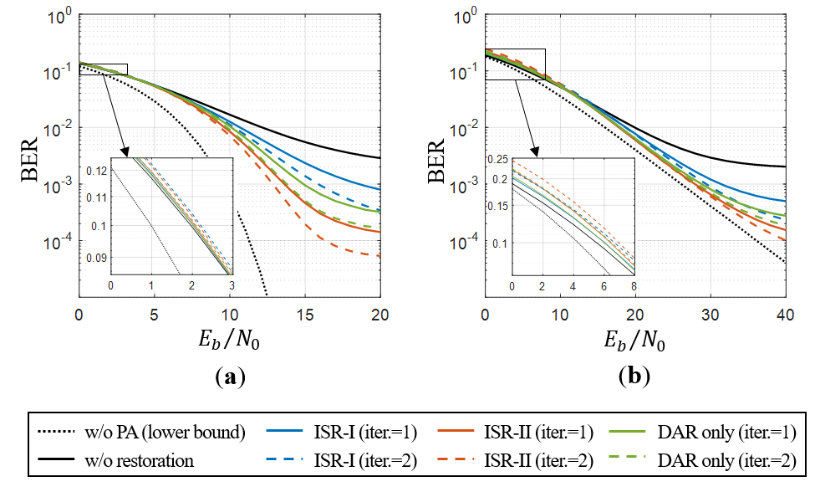
Figure 4.6 BER comparison of different SC schemes for $IBO=\text{3}$ dB over
(a) AWGN and (b) Rayleigh fading channel (16-QAM).

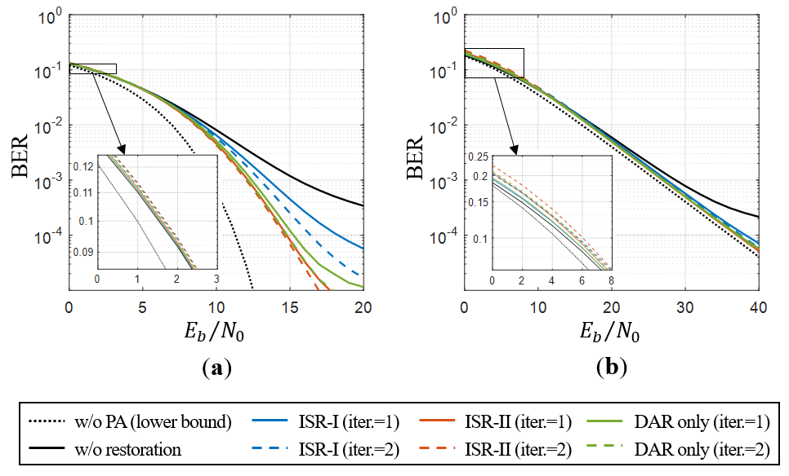
Figure 4.7 BER comparison of different SC schemes for $IBO=\text{4}$ dB over
(a) AWGN and (b) Rayleigh fading channel (16-QAM).
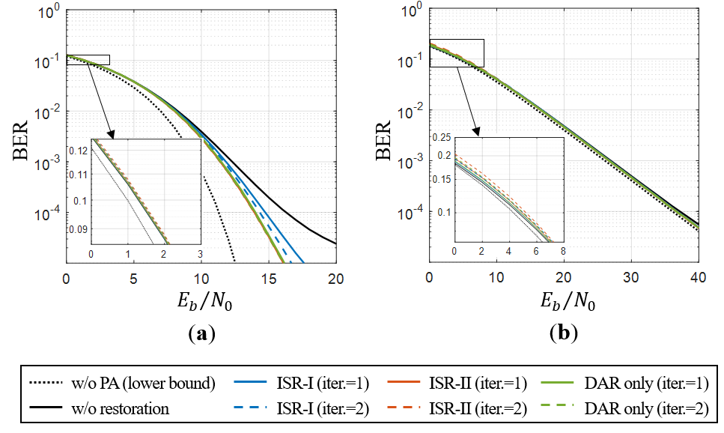
Figure 4.8 BER comparison of different SC schemes for $IBO=\text{5}$ dB over
(a) AWGN and (b) Rayleigh fading channel (16-QAM).
Another important observation is that the ISR schemes have to work under mid-high SNR where otherwise the envelope peak detection could fail most of the time. As shown in Fig. 4.6 to 4.8, the proposed schemes are outperformed by the case of no restoration with low SNR (i.e., ${E_{b}}/{N_{0}}=\text{0–5}$ dB of AWGN and ${E_{b}}/{N_{0}}=\text{0–10}$ dB of Rayleigh fading channel), and their BER performance worsens when more iterations are launched. The above malicious effect is more obvious on ISR-Ⅱ as it suffers more from any error decision.
    - Total Degradation
Let the degradation of power efficiency due to the nonlinear effect be denoted as TD (in dB), which quantifies the difference between the maximum power of PA and the input power of a linear amplifier required to assure a predefined BER [87]. TD is expressed as follows:
$$TD\left[dB\right]=IBO+{\left(\frac{E_{b}}{N_{0}}\right)}_{nonlin.}-{\left(\frac{E_{b}}{N_{0}}\right)}_{lin.}\text{,}$$ | (4.10)
where ${\left({E_{b}}/{N_{0}}\right)}_{lin.}$ and ${\left({E_{b}}/{N_{0}}\right)}_{nonlin.}$ denote as the required SNRs in linear PA and nonlinear PA, respectively. Table 4.3 provides the TD performance of ISR-Ⅱ (with two iterations) for different IBOs and target BERs under Rayleigh fading
Table 4.3 Total degradation (dB) of ISR-Ⅱ versus IBO in Rayleigh fading channel.
IBO [dB] | Target BER
IBO [dB] | $${10}^{-1}$$ | $${10}^{-2}$$ | $${10}^{-3}$$ | $${10}^{-4}$$
2 | 5.75 | 6.03 | unachievable | unachievable
3 | 5.70 | 4.93 | 4.61 | 6.90
4 | 5.80 | 5.09 | 4.89 | 4.96
5 | 5.92 | 5.63 | 5.69 | 5.56

channel. The smallest TD (at about 5 dB) appears at $IBO=\text{3–4}$ dB if the target BERs set to ${10}^{-3}$ and ${10}^{-4}$, respectively. This outcome advocates the analysis result of BER performance, showing that the proposed SC schemes yield the best performance at $IBO=\text{3–4}$ dB.
    - Power Saving Evaluation
The IBO employed at the 802.11ah PA is usually 8–12 dB when being considered for the micro-/pico-cell usage, leading to low PA efficiency [88]. To evaluate the power saving, we consider a linear PA (e.g., Class A and Class B) where linear amplification can be achieved up to the saturation point. We define the actual PA efficiency $η={η_{max}}/{PAPR}$ [17] for power saving measure, where $η_{max}$ is the maximum PA efficiency. The value of PAPR is linearly scaled with IBO as the probability of saturated samples is directionally related to on recovery ability of SC-based schemes. Accordingly, the improvement ratio of PA efficiency can be expressed as
$$∆η=10\log_{10}\left(\frac{η_{2}}{η_{1}}\right)=10\log_{10}\left(\frac{{IBO}_{1}}{{IBO}_{2}}\right)\text{,}$$ | (4.11a)
or
$$∆η={\left[{IBO}_{1}\right]}_{dB}-{\left[{IBO}_{2}\right]}_{dB}\text{,}$$ | (4.11b)
where $η_{1}$ and $η_{2}$ is the PA efficiency for ${IBO}_{1}$ and ${IBO}_{2}$ (${IBO}_{1}>{IBO}_{2}$), respectively. All the simulation results of PSD, BER, and TD indicate that the IBO can be reduced from 8–12 dB to 3–5 dB by applying the proposed scheme (ISR-Ⅱ) with a fair SNR (${E_{b}}/{N_{0}}≥\text{10}$ dB). From Eq. (4.11b), we conclude that our schemes improve the PA efficiency in the range of 3–9 dB; i.e., $∆η=\left[\text{8, 12}\right]-\left[\text{3, 5}\right]=\left[\text{3, 9}\right]$ dB. Such improvement significantly mitigates the PA power consumption and thus is expected to solidly extend the battery lifespan of 802.11ah IoT-UEs.
  - Summary
For an IoT-UE, the power consumption by uplink transmissions highly depends on the output power of the transmitter, which is in turn determined by the PA’s IBO. This chapter introduces a SC scheme, namely ISR, aiming to solidly reduce the required IBO of the uplink transmission for IoT UEs under the 802.11ah specification. To enable effective signal reconstruction, the ISR is based on novel generalization of the Papoulis-Gerchberg algorithm that can handle any signal. We claim that the proposed ISR scheme can completely incorporate with the current industry specification and 802.11ah UEs since all the required prior information and processing, including iterative FFT and hard decision operations, are inherently available in the UEs via system-built-in functions in the RF module. Simulation results demonstrate that the proposed scheme can significantly reduce the required IBO up to 3–5 dB with 4–7 dB total degradation (target bit error rate is ${10}^{-4}$), leading to 3–9 dB improvement of PA efficiency for uplink signaling.

CONCLUDING REMARKS
As CP-OFDM and DFT-s-OFDM underlay the most of multi-RATs in 5G, the PAPR problem for PA nonlinearity is still a long-last standing issue for energy efficiency in wireless communication systems. In this study, we addressed the PAPR issue in a proper manner according to the property of different use cases.
For the scenario of D2D and NTN communications in LTE/NR systems, the transmitter usually utilizes DFT-s-OFDM for power-efficient signaling. We proposed improved GPC and PCC-DFT-s-OFDM to achieve further PAPR reduction adjustably with spectral efficiency as a trade-off at the transmitter. The simulation results show that PCC-DFT-s-OFDM not only improves the performance of PAPR and BER but also the PSD. This enhances the immunity of the frequency-selective fading channel for DFT-s-OFDM signaling. Although the extent of the improvement for PAPR, PSD and BER performances depends on the applied order of PCC mapping $d$, which would decrease data rate $2^{d}$ times, the proposed architecture creates the opportunity for further improvement in terms of PAPR, PSD and BER performances when the channel condition allows bandwidth-greedy transmission. Further, a bit-level PCC mapping scheme, which is developed on the symmetricity of popular Gray code bit labelling, is proposed for making the deployment of the transmitters easier.
For the scenario of 802.11ah systems in LPWA/IoT-based networks, the use of CP-OFDM for UL signaling becomes a bottleneck of UE power-saving that may impair the advantages of 802.11ah on high transmit efficiency of large-size data. To follow a common design principle for an IoT system that leaves all possible complicated operations performed at the AP while making the IoT-UEs as simple as possible, we proposed a receiver-side SC scheme termed ISR, which is based on a novel signal reconstruction method, EPGA. ISR is completely compatible with 802.11ah as it only exploits the prior information available in the standard operations and popular system-build-in functions in the iterative process. Extensive numerical evaluations demonstrate that the proposed scheme can improve PA efficiency by 3–9 dB for UL signaling.
In our future work, we will focus on the mechanism of switching modes between conventional and low-PAPR-oriented transmission toward channel state information (CSI) and overall waveform KPIs. As the proposed improved GPC, PCC-DFT-s-OFDM, and ISR enhanced the flexibility of the trade-off between further PAPR reduction and other capabilities with a standard-compatible manner, the remained issue is to find an optimum set of parameters by a comprehensive simulation. In addition, the popular channel coding techniques such as convolutional, low-density parity-check (LDPC) and Polar code should be also considered in the evaluation of block error rate (BLER) performance since all current wireless communication systems tend to rely on the channel coding. For ISR, there is another important issue to estimate the idle time of 802.11ah APs based on precise traffic modeling. It helps 802.11ah systems to evaluate the available time margins for applying ISR. These further works will make our proposed schemes more practical for use.

REFERENCES
[1] ITU-R, “IMT Vision – Framework and overall objectives of the future development of IMT for 2020 and beyond,” Tech. Rep. M.2083-0, Sep. 2015.
[2] 3rd Generation Partnership Project, “Technical Specification Group Radio Access Network; Study on Multiple Radio Access Technology (Multi-RAT) joint coordination (Release 13),” 3GPP TR 37.870 V13.0.0, Jun. 2015.
[3] Thales, “Study on solutions evaluation for NR to support Non Terrestrial Network,” 3GPP TSG RAN meeting #80, La Jolla, USA, RP-181334, Jun. 2018.
[4] 3rd Generation Partnership Project, “Technical Specification Group Radio Access Network; Study on New Radio (NR) to support non-terrestrial networks (Release 15),” 3GPP TR 38.811 V15.2.0, Sep. 2019.
[5] M. Hasan, S. M. Shahid, S. H. Won, and S. Kwon, “Load Balancing in 5G multi-RAT Networks by Ofﬂoading Delay Tolerant Flows,” presented at the KICS Summer Conference 2019, Jeju, South Korea, Jun. 2019, pp. 1–2.
[6] A. Mourad and P.-H. Kuo, “Multi-RATs Convergence: A New Spin Through the Edge,” London, UK, Dec. 14, 2017, [Online]. Available: https://www.cambridgewireless.co.uk/media/uploads/files/RadioSIG14.12.2017-Interdigital-Ping-Heng_Kuo.pdf.
[7] A. A. Zaidi et al., “Waveform and Numerology to Support 5G Services and Requirements,” IEEE Commun. Mag., vol. 54, no. 11, pp. 90–98, Nov. 2016, doi: 10.1109/MCOM.2016.1600336CM.
[8] A. Hammoodi, L. Audah, and M. A. Taher, “Green Coexistence for 5G Waveform Candidates: A Review,” IEEE Access, vol. 7, pp. 10103–10126, 2019, doi: 10.1109/ACCESS.2019.2891312.
[9] A. F. Demir, M. Elkourdi, M. Ibrahim, and H. Arslan, “Waveform Design for 5G and Beyond,” in 5G Networks: Fundamental Requirements, Enabling Technologies, and Operations Management, Hoboken, NJ, USA: John Wiley & Sons, Inc., 2018, pp. 51–76.
[10] B. Farhang-Boroujeny and H. Moradi, “OFDM Inspired Waveforms for 5G,” IEEE Commun. Surv. Tutor., vol. 18, no. 4, pp. 2474–2492, 2016, doi: 10.1109/COMST.2016.2565566.
[11] G. Wunder, R. F. H. Fischer, H. Boche, S. Litsyn, and J.-S. No, “The PAPR Problem in OFDM Transmission: New Directions for a Long-Lasting Problem,” IEEE Signal Process. Mag., vol. 30, no. 6, pp. 130–144, Nov. 2013, doi: 10.1109/MSP.2012.2218138.
[12] S. H. Han and J. H. Lee, “An overview of peak-to-average power ratio reduction techniques for multicarrier transmission,” IEEE Wirel. Commun., vol. 12, no. 2, pp. 56–65, Apr. 2005, doi: 10.1109/MWC.2005.1421929.
[13] T. Jiang and Y. Wu, “An Overview: Peak-to-Average Power Ratio Reduction Techniques for OFDM Signals,” IEEE Trans. Broadcast., vol. 54, no. 2, pp. 257–268, Jun. 2008, doi: 10.1109/TBC.2008.915770.
[14] Y. Rahmatallah and S. Mohan, “Peak-To-Average Power Ratio Reduction in OFDM Systems: A Survey And Taxonomy,” IEEE Commun. Surv. Tutor., vol. 15, no. 4, pp. 1567–1592, 2013, doi: 10.1109/SURV.2013.021313.00164.
[15] F. Sandoval, G. Poitau, and F. Gagnon, “Hybrid Peak-to-Average Power Ratio Reduction Techniques: Review and Performance Comparison,” IEEE Access, vol. 5, pp. 27145–27161, 2017, doi: 10.1109/ACCESS.2017.2775859.
[16] H. Ochiai and H. Imai, “On the distribution of the peak-to-average power ratio in OFDM signals,” IEEE Trans. Commun., vol. 49, no. 2, pp. 282–289, Feb. 2001, doi: 10.1109/26.905885.
[17] R. J. Baxley and G. T. Zhou, “Power savings analysis of peak-to-average power ratio reduction in OFDM,” IEEE Trans. Consum. Electron., vol. 50, no. 3, pp. 792–798, Aug. 2004, doi: 10.1109/TCE.2004.1341681.
[18] C. Rapp, “Effect of HPA-nonlinearity on 4-DPSK/OFDM-signal for a digital sound broadcasting system,” in Proc. 2nd European Conf. Satellite Commun., Liege, Belgium, Oct. 1991, vol. 2, pp. 179–184.
[19] Ericsson, “Uplink aspects of NR UE power saving,” 3GPP TSG-RAN WG1 Meeting #94bis, Chengdu, China, R1-1811506, Oct. 2018.
[20] A. Ba et al., “A 4mW-RX 7mW-TX IEEE 802.11ah fully-integrated RF transceiver,” in 2017 IEEE Radio Frequency Integrated Circuits Symposium (RFIC), Honolulu, HI, USA, Jun. 2017, pp. 232–235, doi: 10.1109/RFIC.2017.7969060.
[21] Nokia, Alcatel-Lucent Shanghai Bell, “Potential for system level gains with low PAPR waveforms,” 3GPP TSG-RAN WG1 Meeting #86, Gothenburg, Sweden, R1-167795, Aug. 2016.
[22] Y. Hori and H. Ochiai, “A New Uplink Multiple Access Based on OFDM With Low PAPR, Low Latency, and High Reliability,” IEEE Trans. Commun., vol. 66, no. 5, pp. 1996–2008, May 2018, doi: 10.1109/TCOMM.2018.2792486.
[23] A. Jayaprakash et al., “Analysis of Candidate Waveforms for Integrated Satellite-Terrestrial 5G Systems,” in 2019 IEEE 2nd 5G World Forum (5GWF), Dresden, Germany, Sep. 2019, pp. 636–641, doi: 10.1109/5GWF.2019.8911721.
[24] Huawei, HiSilicon, “Discussion on PAPR in NTN,” 3GPP TSG RAN WG1 Meeting #97, Reno, USA, R1-1907516, May 2019.
[25] A. Ikpehai et al., “Low-Power Wide Area Network Technologies for Internet-of-Things: A Comparative Review,” IEEE Internet Things J., pp. 1–1, 2018, doi: 10.1109/JIOT.2018.2883728.
[26] H. Wang and A. O. Fapojuwo, “A Survey of Enabling Technologies of Low Power and Long Range Machine-to-Machine Communications,” IEEE Commun. Surv. Tutor., vol. 19, no. 4, pp. 2621–2639, 2017, doi: 10.1109/COMST.2017.2721379.
[27] L. Chettri and R. Bera, “A Comprehensive Survey on Internet of Things (IoT) Toward 5G Wireless Systems,” IEEE Internet Things J., vol. 7, no. 1, pp. 16–32, Jan. 2020, doi: 10.1109/JIOT.2019.2948888.
[28] “Standardization of NB-IOT completed.” https://www.3gpp.org/news-events/3gpp-news/1785-nb_iot_ (accessed Jun. 18, 2019).
[29] IEEE Std 802.11ah-2016 (Amendment to IEEE Std 802.11-2016, as amended by IEEE Std 802.11ai-2016): IEEE Standard for Information technology--Telecommunications and information exchange between systems - Local and metropolitan area networks--Specific require. S.l.: IEEE, 2017.
[30] A. Rico-Alvarino et al., “An overview of 3GPP enhancements on machine to machine communications,” IEEE Commun. Mag., vol. 54, no. 6, pp. 14–21, Jun. 2016, doi: 10.1109/MCOM.2016.7497761.
[31] V. Petrov et al., “When IoT Keeps People in the Loop: A Path Towards a New Global Utility,” ArXiv170300541 Cs, Mar. 2017, Accessed: Mar. 27, 2019. [Online]. Available: http://arxiv.org/abs/1703.00541.
[32] E. Morin, M. Maman, R. Guizzetti, and A. Duda, “Comparison of the Device Lifetime in Wireless Networks for the Internet of Things,” IEEE Access, vol. 5, pp. 7097–7114, 2017, doi: 10.1109/ACCESS.2017.2688279.
[33] S. Popli, R. K. Jha, and S. Jain, “A Survey on Energy Efficient Narrowband Internet of Things (NBIoT): Architecture, Application and Challenges,” IEEE Access, vol. 7, pp. 16739–16776, 2019, doi: 10.1109/ACCESS.2018.2881533.
[34] Technical Specification Group Radio Access Network; Evolved Universal Terrestrial Radio Access (E-UTRA); Physical channels and modulation (Release 15). 3rd Generation Partnership Project Std. 3GPP TS 36.211 V15.4.0, 2018.
[35] X. Yu et al., “A Sub-GHz low-power transceiver with PAPR-tolerant power amplifier for 802.11ah applications,” in 2015 IEEE Radio Frequency Integrated Circuits Symposium (RFIC), Phoenix, AZ, USA, May 2015, pp. 231–234, doi: 10.1109/RFIC.2015.7337747.
[36] N. Andrade, P. Toledo, G. Guimaraes, H. Klimach, H. Dornelas, and S. Bampi, “Low power IEEE 802.11ah receiver system-level design aiming for IoT applications,” in Proceedings of the 30th Symposium on Integrated Circuits and Systems Design Chip on the Sands - SBCCI ’17, Fortaleza, Ceará, Brazil, 2017, pp. 11–16, doi: 10.1145/3109984.3110013.
[37] M. Wei et al., “A fully integrated reconfigurable low-power Sub-GHz transceiver for 802.11ah in 65nm CMOS,” in 2017 IEEE Radio Frequency Integrated Circuits Symposium (RFIC), Honolulu, HI, USA, Jun. 2017, pp. 240–243, doi: 10.1109/RFIC.2017.7969062.
[38] Y. Zhao, O. N. C. Yilmaz, and A. Larmo, “Optimizing M2M Energy Efficiency in IEEE 802.11ah,” in 2015 IEEE Globecom Workshops (GC Wkshps), San Diego, CA, USA, Dec. 2015, pp. 1–6, doi: 10.1109/GLOCOMW.2015.7414004.
[39] L. Beltramelli, P. Osterberg, U. Jennehag, and M. Gidlund, “Hybrid MAC mechanism for energy efficient communication in IEEE 802.11ah,” in 2017 IEEE International Conference on Industrial Technology (ICIT), Toronto, ON, Mar. 2017, pp. 1295–1300, doi: 10.1109/ICIT.2017.7915550.
[40] T. Kim and J. M. Chang, “Enhanced Power Saving Mechanism for Large-Scale 802.11ah Wireless Sensor Networks,” IEEE Trans. Green Commun. Netw., vol. 1, no. 4, pp. 516–527, Dec. 2017, doi: 10.1109/TGCN.2017.2727056.
[41] E. Khorov et al., “Enabling the Internet of Things With Wi-Fi Halow—Performance Evaluation of the Restricted Access Window,” IEEE Access, vol. 7, pp. 127402–127415, 2019, doi: 10.1109/ACCESS.2019.2939760.
[42] E. Olfat and M. Bengtsson, “Joint Channel and Clipping Level Estimation for OFDM in IoT-based Networks,” IEEE Trans. Signal Process., vol. 65, no. 18, pp. 4902–4911, Sep. 2017, doi: 10.1109/TSP.2017.2713765.
[43] L. Cho, X.-H. Yu, C.-Y. Chen, and C.-Y. Hsu, “Green OFDM for IoT: Minimizing IBO subject to a spectral mask,” in 2018 IEEE International Conference on Applied System Invention (ICASI), Chiba, Japan, Apr. 2018, pp. 5–8, doi: 10.1109/ICASI.2018.8394252.
[44] E. Soltanmohammadi, K. Ghavami, and M. Naraghi-Pour, “A Survey of Traffic Issues in Machine-to-Machine Communications Over LTE,” IEEE Internet Things J., vol. 3, no. 6, pp. 865–884, Dec. 2016, doi: 10.1109/JIOT.2016.2533541.
[45] F. Ghavimi and H.-H. Chen, “M2M Communications in 3GPP LTE/LTE-A Networks: Architectures, Service Requirements, Challenges, and Applications,” IEEE Commun. Surv. Tutor., vol. 17, no. 2, pp. 525–549, 2015, doi: 10.1109/COMST.2014.2361626.
[46] Y. Sui et al., “Adaptive Elastic Echo State Network for Channel Prediction in IEEE802.11ah Standard-Based OFDM System,” IEEE Access, vol. 8, pp. 10169–10185, 2020, doi: 10.1109/ACCESS.2020.2964810.
[47] 3rd Generation Partnership Project, “Technical Specification Group Radio Access Network; Study on provision of low-cost Machine-Type Communications (MTC) User Equipments (UEs) based on LTE (Release 12),” 3GPP TR 36.888 V12.0.0, Jun. 2013.
[48] Morse Micro, “WHITE PAPER: Wi-Fi HaLow Power Consumption,” National Innovation Centre, Eveleigh, NSW 2015, Australia, Jan. 2019.
[49] L. Guan and A. Zhu, “Green Communications: Digital Predistortion for Wideband RF Power Amplifiers,” IEEE Microw. Mag., vol. 15, no. 7, pp. 84–99, Nov. 2014, doi: 10.1109/MMM.2014.2356037.
[50] Technical Specification Group Radio Access Network; Evolved Universal Terrestrial Radio Access (E-UTRA); Physical channels and modulation (Release 15). 3rd Generation Partnership Project Std. 3GPP TS 36.211 V15.7.0, 2019.
[51] Technical Specification Group Radio Access Network; NR; Physical channels and modulation (Release 15). 3rd Generation Partnership Project Std. 3GPP TS 38.211 V15.7.0, 2019.
[52] H. Myung, J. Lim, and D. Goodman, “Single carrier FDMA for uplink wireless transmission,” IEEE Veh. Technol. Mag., vol. 1, no. 3, pp. 30–38, Sep. 2006, doi: 10.1109/MVT.2006.307304.
[53] Technical Specification Group Radio Access Network; Evolved Universal Terrestrial Radio Access (E-UTRA); Physical channels and modulation (Release 13). 3rd Generation Partnership Project Std. 3GPP TS 36.211 V13.3.0, 2016.
[54] Qualcomm Inc., “Coverage analysis of DFT-s-OFDM and OFDM with low PAPR techniques,” 3GPP TSG-RAN WG1 #86, Lisbon, Portugal, R1-1610113, Oct. 2016.
[55] Samsung, “Frequency domain spectrum shaping for DFT-s-OFDM,” 3GPP TSG RAN WG1 Meeting #88, Athens, Greece, R1-1703016, Feb. 2017.
[56] Nokia, Alcatel-Lucent Shanghai Bell, “Rotated modulations for DFT-s-OFDM uplink,” 3GPP TSG-RAN WG4 #82, Athens, Greece, R4-1700726, Feb. 2017.
[57] Ericsson, “PAPR reduction for NTN,” 3GPP TSG-RAN WG1 Meeting #97, Reno, USA, R1-1907431, May 2019.
[58] A. Kakkavas, W. Xu, J. Luo, M. Castaneda, and J. A. Nossek, “On PAPR characteristics of DFT-s-OFDM with geometric and probabilistic constellation shaping,” in 2017 IEEE 18th International Workshop on Signal Processing Advances in Wireless Communications (SPAWC), Sapporo, Jul. 2017, pp. 1–5, doi: 10.1109/SPAWC.2017.8227810.
[59] Feng-Wen Sun and H. C. A. van Tilborg, “Approaching capacity by equiprobable signaling on the Gaussian channel,” IEEE Trans. Inf. Theory, vol. 39, no. 5, pp. 1714–1716, Sep. 1993, doi: 10.1109/18.259663.
[60] F. R. Kschischang and S. Pasupathy, “Optimal nonuniform signaling for Gaussian channels,” IEEE Trans. Inf. Theory, vol. 39, no. 3, pp. 913–929, May 1993, doi: 10.1109/18.256499.
[61] Sony, “Performance of Non-Uniform Constellations in NR,” 3GPP TSG RAN WG1 #87, Reno, Nevada, USA, R1-1611543, Nov. 2016.
[62] Huawei, HiSilicon, “Signal Shaping for QAM Constellations,” 3GPP TSG RAN WG1 Meeting #88, Athens, Greece, R1-1701713, Feb. 2017.
[63] O. Mauritz and B. Popovic, “Optimum Family of Spectrum-Shaping Functions for PAPR Reduction of DFT-Spread OFDM Signals,” in IEEE Vehicular Technology Conference, Hyatt Regency Montreal, Montreal, QC, Canada, Sep. 2006, pp. 1–5, doi: 10.1109/VTCF.2006.294.
[64] Huawei, HiSilicon, “Performance evaluation for pi/2 BPSK with FDSS,” 3GPP TSG RAN WG1 Meeting #88bis, Spokane, USA, R1-1705060, Apr. 2017.
[65] C.-Y. Hsu and H.-C. Liao, “Generalised precoding method for PAPR reduction with low complexity in OFDM systems,” IET Commun., vol. 12, no. 7, pp. 796–808, Apr. 2018, doi: 10.1049/iet-com.2017.0824.
[66] X. Ouyang, J. Jin, G. Jin, and Z. Wang, “Low complexity discrete Hartley transform precoded OFDM for peak power reduction,” Electron. Lett., vol. 48, no. 2, p. 90, 2012, doi: 10.1049/el.2011.3283.
[67] I. Baig and V. Jeoti, “A new ZCT precoded OFDM system with pulse shaping: PAPR analysis,” in 2010 IEEE Asia Pacific Conference on Circuits and Systems, Kuala Lumpur, Malaysia, Dec. 2010, pp. 1131–1134, doi: 10.1109/APCCAS.2010.5775063.
[68] J. Tellado, L. M. C. Hoo, and J. M. Cioffi, “Maximum-likelihood detection of nonlinearly distorted multicarrier symbols by iterative decoding,” IEEE Trans. Commun., vol. 51, no. 2, pp. 218–228, Feb. 2003, doi: 10.1109/TCOMM.2003.809289.
[69] J. Guerreiro, R. Dinis, and P. Montezuma, “Optimum and Sub-Optimum Receivers for OFDM Signals with Strong Nonlinear Distortion Effects,” IEEE Trans. Commun., vol. 61, no. 9, pp. 3830–3840, Sep. 2013, doi: 10.1109/TCOMM.2013.072913.120344.
[70] N. Regev, I. Iofedov, and D. Wulich, “Maximum Likelihood Detection of Nonlinearly Distorted OFDM Signal,” in 2015 IEEE Global Communications Conference (GLOBECOM), San Diego, CA, USA, Dec. 2015, pp. 1–6, doi: 10.1109/GLOCOM.2015.7417009.
[71] Hangjun Chen and A. M. Haimovich, “Iterative estimation and cancellation of clipping noise for OFDM signals,” IEEE Commun. Lett., vol. 7, no. 7, pp. 305–307, Jul. 2003, doi: 10.1109/LCOMM.2003.814720.
[72] I. Gutman, I. Iofedov, and D. Wulich, “Iterative Decoding of Iterative Clipped and Filtered OFDM Signal,” IEEE Trans. Commun., vol. 61, no. 10, pp. 4284–4293, Oct. 2013, doi: 10.1109/TCOMM.2013.090513.120983.
[73] S. Dimitrov, “Iterative Cancellation of Non-Linear Distortion Noise in Digital Communication Systems,” IEEE Trans. Commun., vol. 63, no. 6, pp. 2325–2336, Jun. 2015, doi: 10.1109/TCOMM.2015.2424241.
[74] L. Yang, K. Song, and Y. M. Siu, “Iterative Clipping Noise Recovery of OFDM Signals Based on Compressed Sensing,” IEEE Trans. Broadcast., vol. 63, no. 4, pp. 706–713, Dec. 2017, doi: 10.1109/TBC.2017.2669641.
[75] S. Liang, J. Tong, and L. Ping, “On Iterative Compensation of Clipping Distortion in OFDM Systems,” IEEE Wirel. Commun. Lett., vol. 8, no. 2, pp. 436–439, Apr. 2019, doi: 10.1109/LWC.2018.2874935.
[76] L. Cho, H.-C. Liao, and C.-Y. Hsu, “Adjustable PAPR reduction for DFT-s-OFDM via improved general precoding scheme,” Electron. Lett., vol. 54, no. 14, pp. 903–905, Jul. 2018, doi: 10.1049/el.2018.0743.
[77] L. Cho, Y.-M. Kuo, Y.-S. Wu, and C.-Y. Hsu, “Polynomial Cancellation Coded DFT-s-OFDM for Low-PAPR Uplink Signaling,” Electronics, vol. 8, no. 11, p. 1349, Nov. 2019, doi: 10.3390/electronics8111349.
[78] L. Cho and C.-Y. Hsu, “Bit-level implementation for polynomial cancellation coded DFT-s-OFDM transmitters,” Electron. Lett., vol. 56, no. 5, pp. 250–252, Mar. 2020, doi: 10.1049/el.2019.3768.
[79] H. Ochiai, “On Instantaneous Power Distributions of Single-Carrier FDMA Signals,” IEEE Wirel. Commun. Lett., vol. 1, no. 2, pp. 73–76, Apr. 2012, doi: 10.1109/WCL.2012.012012.110254.
[80] H.-C. Liao, “Studies of Precoding Technique for Reduction of Peak to Average Power Ratio of OFDM,” Ph.D. dissertation, Graduate Institute of Communication Engineering, Tatung University, Taipei, Taiwan, 2018.
[81] J. Armstrong, P. M. Grant, and G. Povey, “Polynomial cancellation coding of OFDM to reduce intercarrier interference due to Doppler spread,” in Proc. IEEE Global Telecommun. Conf. (GLOBECOM), Sydney, Australia, 1998, vol. 5, pp. 2771–2776, doi: 10.1109/GLOCOM.1998.776492.
[82] G. Kongara, C. He, L. Yang, and J. Armstrong, “A Comparison of CP-OFDM, PCC-OFDM and UFMC for 5G Uplink Communications,” IEEE Access, vol. 7, pp. 157574–157594, 2019, doi: 10.1109/ACCESS.2019.2949792.
[83] H. Ali and R. Yaqub, “A Low Complexity Linear Moving Average Filtering Technique for PAR Reduction in OFDM Systems,” Int. J. Commun. Netw. Syst. Sci., vol. 11, no. 10, pp. 199–215, 2018, doi: 10.4236/ijcns.2018.1110012.
[84] L. Cho, C.-Y. Chen, C.-K. Lin, and C.-Y. Hsu, “The convergence analysis of extended Papoulis-Gerchberg Algorithm on AWGN-smeared signals,” in 2018 IEEE International Conference on Applied System Invention (ICASI), Apr. 2018, pp. 730–733, doi: 10.1109/ICASI.2018.8394363.
[85] Dukhyun Kim and G. L. Stuber, “Clipping noise mitigation for OFDM by decision-aided reconstruction,” IEEE Commun. Lett., vol. 3, no. 1, pp. 4–6, Jan. 1999, doi: 10.1109/4234.740112.
[86] Y.-C. Wang and Z.-Q. Luo, “Optimized Iterative Clipping and Filtering for PAPR Reduction of OFDM Signals,” IEEE Trans. Commun., vol. 59, no. 1, pp. 33–37, Jan. 2011, doi: 10.1109/TCOMM.2010.102910.090040.
[87] S. C. Thompson, J. G. Proakis, and J. R. Zeidler, “The effectiveness of signal clipping for PAPR and total degradation reduction in OFDM systems,” in GLOBECOM ’05. IEEE Global Telecommunications Conference, 2005., St. Louis, MO, USA, 2005, pp. 2807–2811, doi: 10.1109/GLOCOM.2005.1578271.
[88] “Deliverable D2.3, energy efficiency analysis of the reference systems, areas of improvements and target breakdown,” Brussels, Belgium, INFSO-ICT-247733, Jan. 2012.

APPENDIX
In this appendix, the derivation of spectral shaping function of PCC-DFT-s-OFDM is shown. For the $d$-order PCC-DFT-s-OFDM, its SS function, $G_{k}^{d}=\sum_{u=0}^{2^{d}-1}{{\left({-W}_{M}^{k}\right)}^{u}}$, $0≤k≤M-1$, can be extracted by Eq. (3.16) and rewritten as follows:
$$G_{k}^{d}=\sum_{u=0}^{2^{d}-1}{{\left({-W}_{N_{d}}^{k}\right)}^{u}}=\frac{1-{\left(-W_{N_{d}}^{k}\right)}^{2^{d}}}{1+W_{N_{d}}^{k}}=\frac{1-W_{N_{d}}^{2^{d}k}}{1+W_{N_{d}}^{k}}$$  $$=\frac{\left(1+W_{N_{d}}^{2^{d-1}k}\right)\left(1+W_{N_{d}}^{2^{d-2}k}\right)…\left(1+W_{N_{d}}^{2^{d-d}k}\right)\left(1-W_{N_{d}}^{2^{d-d}k}\right)}{1+W_{N_{d}}^{k}}$$  $$=\left(1-W_{N_{d}}^{k}\right)\prod_{p=1}^{d-1}{\left(1+W_{N_{d}}^{2^{d-p}k}\right)}$$  $$=2j⋅W_{N_{d}}^{\frac{k}{2}}\left(\frac{W_{N_{d}}^{-\frac{k}{2}}-W_{N_{d}}^{\frac{k}{2}}}{2j}\right)\prod_{p=1}^{d-1}{W_{N_{d}}^{2^{d-p-1}k}2\left(\frac{W_{N_{d}}^{2^{d-p-1}k}+W_{N_{d}}^{2^{d-p-1}k}}{2}\right)}$$  $$=2j⋅W_{N_{d}}^{\frac{k}{2}}\sin\left(\frac{2π}{N_{d}}×\frac{k}{2}\right)\prod_{p=1}^{d-1}{W_{N_{d}}^{2^{d-p-1}k}2\cos\left(\frac{2π}{N_{d}}×2^{d-p-1}k\right)}$$  $$=\underset{\text{Amplitude Response}}{\underbrace{2^{d}\sin\left(\frac{πk}{N_{d}}\right)\prod_{p=1}^{d-1}{\cos\left(\frac{2^{d-p}πk}{N_{d}}\right)}}}\underset{\text{Phase Response}}{\underbrace{e^{j\frac{π}{2}}\prod_{p=1}^{d}{W_{N_{d}}^{2^{d-p-1}k}}}}\text{, }0≤k≤N_{d}-1.$$ | (A.1)
Since the term of $\prod_{p=1}^{d-1}{\cos\left(\frac{2^{d-p}πk}{N_{d}}\right)}$ in the amplitude response is invalid if $d=1$, we define a function $G\left[k\right]$ described in Eq. (3.18) for the validity. Consequently, Eq. (3.17) is derived.

PUBLICATION LIST
Journal Papers
- Li Cho and Chau-Yun Hsu, “Bit-level Implementation for Polynomial Cancellation Coded DFT-s-OFDM Transmitters,” Electronics Letters, vol. 56, no. 5, pp. 250–252, Mar. 2020. (SCI, IF:1.343)
- Li Cho, Yu-Ming Kuo, Yi-Shin Wu, and Chau-Yun Hsu, “Polynomial Cancellation Coded DFT-s-OFDM for Low-PAPR Uplink Signaling,” Electronics, vol. 8, no. 11, p. 1349, Nov. 2019. (SCI, IF:1.764)
- Li Cho, Hsuan-Chun Liao, and Chau-Yun Hsu, “Adjustable PAPR reduction for DFT-s-OFDM via improved General Precoding scheme,” Electronics Letters, vol. 54, no. 14, pp. 903–905, Jul. 2018. (SCI, IF:1.232)
- Li Cho, Xian-Hua Yu, Chau-Yun Hsu, Pin-Han Ho, “Mitigation of OFDM Nonlinearity for IEEE 802.11ah Power-Efficient Uplink via Iterative Subcarrier Regularization,” submitted to IEEE Internet of Things Journal.
Conference Papers
- Li Cho, Meng-Fan Chuang, Sheng-Hsiang Fu, and Chau-Yun Hsu, “BER Reduction for PSK-Based MM-OFDM-BIM with Two-Level Symbol Power,” in Proc. IEEE 22nd International Conference on Advanced Communications Technology (ICACT), Pyeongchang, South Korea, 2020, pp.104–108. (EI)
- Li Cho, Chun-Wei Li, Wei-Chieh Chen, Chau-Yun Hsu, Hong-Ren Wang, and Chang-Ping Lin, “Study of Features and Number of Time Steps to Improve Hourly Solar Power Forecasting via LSTM,” in Proc. IEEE 8th Global Conference on Consumer Electronics (GCCE), Osaka, Japan, 2019, pp. 303–304. (EI)
- Li Cho, Yu-Ming Kuo, Chau-Yun Hsu, and Yi-Shin Wu, “Multiple-Mode OFDM with Block-Wise Index Modulation,” in Proc. 2nd International Conference on Communication Engineering and Technology (ICCET), Nagoya, Japan, 2019, pp. 43–47. (EI)
- Li Cho, Yu-Ming Kuo, and Chau-Yun Hsu, “Rotated DFT-Spread OFDM for Low-PAPR Transmissions,” in Proc. IEEE 3rd International Conference on Communication and Information Systems (ICCIS), Singapore, Singapore, 2018, pp. 146–149. (EI)
- Li Cho, Cheng-Yu Chen, Chieh-Ke Lin, and Chau-Yun Hsu, “The Convergence Analysis of Extended Papoulis-Gerchberg Algorithm on AWGN-Smeared Signals,” in Proc. 4th IEEE International Conference on Applied System Invention (ICASI), Chiba, Japan, Apr. 2018, pp. 730–733. (Best Paper Award, EI)
- Li Cho, Xian-Hua Yu, Cheng-Yu Chen, and Chau-Yun Hsu, “Green OFDM for IoT: Minimizing IBO Subject to a Spectral Mask,” in Proc. 4th IEEE International Conference on Applied System Invention (ICASI), Chiba, Japan, Apr. 2018, pp. 5–8. (EI)
- Li Cho, Chia-Huei Ting, Cheng-Yu Chen, Chang-Hao Yau, and Chau-Yun Hsu, “When UUDN meets 5G waveforms: New challenge of signal linearity?” in Proc. 3rd IEEE International Conference on Applied System Invention (ICASI), Sapporo, Japan, May 2017, pp. 770–773. (EI)

VITA


Li Cho was born in Taipei, Taiwan, in 1987. He received the B.S. degree in electrical engineering from Tatung University, Taipei, Taiwan, and the M.S. and Ph.D. degrees in communication engineering, in 2009, 2010 and 2020, respectively. He served in the government from 2010 to 2017. Since September 2019, he is an Adjunct Instructor with the Department of Electrical Engineering at Tatung University. His research interests include multicarrier communications, index modulation, signal restoration algorithms, and machine learning.

In general, the terminal devices terms CD in IEEE documents and UE in 3GPP documents. This dissertation uses UE for the consistency.
The SS schemes can reduce the signal’s PAPR without extra subcarriers while it would cause severe BER degradation.
Both operations can be reduced to $O\left(N_{d}\log_{2}{N_{d}}\right)$ if split-radix FFT is applied.
Length of channel impulse response ($L$) is assumed to equal the CP length in the simulation.
The frequency is normalized to User 1’s bandwidth.

